An Excerpt From:

Agile Development Primer
Integrating Agile Development in the Real World

by Peter Schuh

Charles River Media © 2005

Table of Contents
Chapter 1: Agile Development Primer 5
WHAT IS AGILE DEVELOPMENT? 5
THE AGILE METHODOLOGIES 5
AGILE VALUES 6
Individuals and Interactions 6
Working Software 7
Customer Collaboration 7
Responding to Change 7
AGILE PRACTICES 8
AGILE PRINCIPLES 8
Chapter 2: Agile Characteristics 10
THE CHARACTERISTICS OF AN AGILE PROJECT 10
THE DEVELOPMENT TEAM 11
Project Management 12
The Customer 13
Processes and Tools 14
The Contract 15
AGILE PRACTICES, NON-AGILE VALUES 15
WHAT PROJECTS CAN BENEFIT FROM AGILE DEVELOPMENT? 16
STARTING MONDAY: ASSESSING YOUR PROJECT ENVIRONMENT 17
Chapter 3: The Agile Methodologies 20
COMMON THEMES 20
METHODOLOGY DESCRIPTIONS 20
EXTREME PROGRAMMING (XP) 21
Programmer-Centric, Test-Infected 21
Four Values, Twelve Practices 22
Highly Iterative 23
Small Teams, Engaged Customer 24
See Also 24
SCRUM 24
Empirical Process Control 25
Self-Managed Team, Scrum Master, Product Owner, and Everyone Else 25
Timeboxed and Sprint Driven 26
Little Assembly Required and Scalable 26
See Also 27
FEATURE-DRIVEN DEVELOPMENT (FDD) 27
Eight Best Practices 28
Model Initiated, Feature Driven, Reporting Minded 29
Scalable, Prefabricated Approach 31
See Also 31
THE CRYSTAL METHODOLOGIES 31
Project Size and Criticality 32
Working with Human Nature 33
Crystal Clear 34
Crystal Orange 35
Just Enough Process and Very Flexible 35
See Also 36
ADAPTIVE SOFTWARE DEVELOPMENT (ASD) 36
The Adaptive Lifecycle 36
Foster Collaboration Among Individuals and with the Organization 38
See Also 39
DYNAMIC SYSTEMS DEVELOPMENT METHOD (DSDM™)^{[1]} 39
The Nine Principles of DSDM 39
A Seven-Phase Approach 40
Tried, Tested, and Enterprise Ready 41
See Also 41
LEAN SOFTWARE DEVELOPMENT 41
Lean Thinking 41
Seven Principles^{[2]} 42
See Also 43
STARTING MONDAY: INVESTIGATE FURTHER 43
Chapter 4: Selecting an Approach That Fits 45
CHOOSING BETWEEN AN AGILE AND A TRADITIONAL APPROACH 45
Size 45
Criticality 46
Personnel 47
Environment 48
SELECTING THE RIGHT AGILE APPROACH 49
By the Book 49
Modified or Partial Implementation 49
Embedded XP 50
Mix and Match 50
Chapter 5: Going Agile 52
IS THE TEAM READY? 52
ANNOUNCING THE TEAM’S INTENTION TO GO AGILE 52
Full Transition 53
Gradual Adoption 53
ENCOUNTERING, ADDRESSING, AND OVERCOMING RESISTANCE 54
People Who Like Meetings and Documents 54
Fears of Micromanagement 55
Business and Upper Management Do Not Want to Give Up Control 55
Analysts and Testers 56
When Agile Is a Four-Letter Word 56
STARTING WITH THE BARE MINIMUM 57
ALTERING THE PROJECT ENVIRONMENT 57
Adjust with Many Microtouches 58
Eliminate Waste 58
ITERATION ZERO 59
DISCONTINUE A PROCESS ONCE IT HAS SERVED ITS PURPOSE 60
FALSE AGILE PRACTITIONERS AND PROJECTS 61
STARTING MONDAY: MEASURING THE TEAM’S PROGRESS 62
Chapter 6: Agile Practices 63
WHERE TO START? 63
SELECTING THE NEXT PRACTICE 64
Current Worst Problem 64
Biggest Bang for the Buck 64
Easiest Thing First, Hardest Second 65
REJECTING A PRACTICE 65
ADOPT PRACTICES BEFORE TOOLS 66
LEARN PROGRAMMING PRACTICES IN PAIRS 67
AGILE PRACTICES IN THIS BOOK 68
Agile Practices Explained 68
Why These Practices Were Chosen 69

Chapter 1: Agile Development Primer
Readers of this book have gleaned their knowledge of agile development by various means. Some may have used an agile methodology for a couple years and are now venturing beyond that methodology’s self-described limitations. Others may be relatively new to agile development, with a few months or a few practices under their belts, but have already faced real-world issues that the named methodologies have not addressed. Others may be project managers or team leads who have seen some of what agile practices can deliver but are not yet convinced that agile development can adapt itself to their heavy-process, fixed-cost, complex-system, or otherwise change-adverse environments. While this book is not intended as an introduction to agile development, it is intended not to alienate but rather to welcome the reader who has some hands-on experience with agile development but has chosen this as his first book to read on the topic. This chapter provides a quick synopsis Of agile development. It will provide the less-informed reader with the background he needs to start reading this book.

WHAT IS AGILE DEVELOPMENT?
Agile development is a method of building software by empowering and trusting people, acknowledging change as a norm, and promoting constant feedback.
Agile development is a countermovement to 30 years of increasingly heavy-handed process meant to refashion computer programming into software engineering, rendering it as manageable and predictable as any other engineering discipline. It is a direct refutation of the notions that people are fungible resources and that software modules can be stamped out like so many widgets off a factory line.
The practices of agile development are not new. Agilists readily admit that for decades there have been teams that have written reusable tests, delivered frequent and small releases, and even programmed in pairs. Rather, agile development is novel because the people behind the movement have catalogued and proofed these agile practices, fused them with core values about people and project environments, and stated in real and valuable ways how to go about building software better.

THE AGILE METHODOLOGIES
Agile development is an umbrella term used to describe a specific group of methodologies that arose out of a growing discontent with the way software development has been approached for the past 30 years. It is important to note that agile development itself is not a methodology. Instead, agile development is a set of fundamental principles about how software should be developed. The best known of a growing number of software development methodologies that subscribe to the principles underpinning agile development include:
- Adaptive Software Development (ASD)
- The Crystal Methodologies
- Dynamic Systems Development Method (DSDM)
- Extreme Programming (XP)
- Feature-Driven Development (FDD)
- Lean Software Development
- Scrum
Although they have similar values and practices, each of these methodologies approaches software development differently. Some are more management and communication focused (such as Scrum and ASD), while others zero in on programmers and development practices (such as XP). Similarly, some methodologies specify clearly what processes a team should follow (such as FDD), and others advocate tailored processes for every project (Crystal).

AGILE VALUES
The values behind agile development are best summarized by the Manifesto for Agile Software Development [Manifesto01]:
We are uncovering better ways of developing software by doing it and helping others do it. Through this work we have come to value:
Individuals and interactions over processes and tools
Working software over comprehensive documentation
Customer collaboration over contract negotiation
Responding to change over following a plan
That is, while there is value in the items on the right, we value the items on the left more.^{[1]}
This is much more than a pretty piece of prose. Each of the four points embedded within the declaration first identifies a fundamental value in agile development and then anchors it to a necessary (though less valuable) aspect of software development. The Agile Manifesto (admittedly highfalutin language) brings us back to the basics of software development.

Individuals and Interactions
People work together to write software. Agile development puts a high value on those professionals who comprise a project team because the success of that team relies upon the skills, effort, and actions of each of its members. For their project to succeed, a team of individuals must select and implement a set of processes and tools that fits its environment, its technology, and its goal. A team with a prefabricated set of tools and process forced upon it is as likely to succeed as it is to fail.

Working Software
Software is meant to do something, and what the software does should be useful. Agile development recognizes that no stack of requirements, analysis, architecture, or design documentation—no matter how high—has value if it does not accompany an operational system. Working software should be the first measure by which a project is evaluated. Documentation can foster the continued delivery of working software, but excessive documentation too early in the development process can at the very least be a waste of time (if it is neglected after it is written) and at the very worst can kill a project (when updating documentation becomes more important than writing code).

Customer Collaboration
Agile development believes IT professionals work in teams to write software for customers. This may sound utterly obvious, but only until one works on a few non-agile projects. The unfortunate truth is that process, tools, and documentation (implemented from both within and outside of the development team) can and too often does separate the project from its purpose. Too often things go bad because the project team is too busy working to the letter of the contract, or things have gone bad so the project team starts working to the letter of the contract (this being the same difference). Agile teams follow practices that keep them focused on the needs of their customers. Agile development advocates only those contractual relationships that encourage the project team to work with and for its customer.

Responding to Change
Change happens. Either a project team fashions itself to work with change or it delivers lower-value software. Agile development stresses practices that enable teams to adjust to changing requirements and system environments. Short feedback loops are an essential component of many of these practices. They help to provide all individuals on the team (whether members of development, management, or the business) with the information they need to make timely decisions. High quality and flexible code is an essential goal among many agile practices. Timely response to change is possible only when the system being developed is amenable to change. Finally, when requirements and environments change, plans must be made so that they can follow.
In short, agile development strives for an empowered development team that responds to change and collaborates with its customer to deliver software with real business value. Processes, tools, plans, documentation, and contracts must be tailored and applied as necessary to achieve this goal.
^{[1]}© 2001. Kent Beck, Mike Beedle, Arie van Bennekum, Alistair Cockburn, Ward Cunningham, Martin Fowler, James Grenning, Jim Highsmith, Andrew Hunt, Ron Jeffries, Jon Kern, Brian Marick, Robert C. Martin, Steve Mellor, Ken Schwaber, Jeff Sutherland, Dave Thomas. This declaration may be freely copied in any form, but only in its entirety through this notice.

AGILE PRACTICES
These are the tools of the agile trade. They are the things agile teams do on a daily basis to stay disciplined, foster communication, remain flexible, and deliver software. Agile practices include many well-known techniques such as automated testing, continuous integration, daily Scrum, collocated team, and pair programming. These practices are shared across the agile methodologies. Not all of them (such as pair programming) are endorsed by every methodology, nor will two project teams following the same methodology necessarily implement the same set of agile practices. Each agile methodology recommends and each team selects a set of practices that best fits the environment and needs of a given project.
Many agile practices address the activities of programmers, while others speak to management processes. Agile practices operate in conjunction with and in support of agile values. They are shared across the agile methodologies. Some methodologies, such as XP, are very specific in the practices they prescribe; others, such as Crystal, leave it almost entirely up to the project team to decide.
Most agile practices did not start with agile development. Project teams have been following them for decades. Agile development, however, has done us the great service of exploring these practices in depth, documenting them extensively, marking routes and hazards, and—where necessary—blazing trails.
Agile practices are only as good as the programmers and managers who select, apply, modify, and follow them. They can be applied at the wrong times, and they can be applied incorrectly. As with any other development process, the misuse of an agile practice can slow down a team, and its use as a bludgeon can beat down a team. Of course, all of this rarely happens when teams adhere to agile values.
Finally, the agile practices discussed in this book are all prefaced with “Agile Practice” so as to be readily identifiable and easy to locate.

AGILE PRINCIPLES
The authors of the Manifesto for Agile Software Development also penned a short document known as the “Principles Behind the Agile Manifesto.” To the agile methodologies and those who practice them, this document is something more than recommended guidelines and something a bit less than creed [Manifesto01].
We follow these principles:
- Our highest priority is to satisfy the customer through early and continuous delivery of valuable software.
- Welcome changing requirements, even late in development. Agile processes harness change for the customer’s competitive advantage.
- Deliver working software frequently, from a couple of weeks to a couple of months, with a preference to the shorter timescale.
- Business people and developers must work together daily throughout the project.
- Build projects around motivated individuals.
- Give them the environment and support they need, and trust them to get the job done.
- The most efficient and effective method of conveying information to and within a development team is face-to-face conversation.
- Working software is the primary measure of progress.
- Agile processes promote sustainable development.
- The sponsors, developers, and users should be able to maintain a constant pace indefinitely.
- Continuous attention to technical excellence and good design enhances agility.
- Simplicity—the art of maximizing the amount of work not done—is essential.
- The best architectures, requirements, and designs emerge from self-organizing teams.
- At regular intervals, the team reflects on how to become more effective, then tunes and adjusts its behavior accordingly.
All agile methodologies are meant to adhere to these principles. They are good thoughts to keep in mind and worth revisiting on occasion.
Nonetheless, throughout this book, we will address projects, situations, and environments where one or more of these principles must be compromised. Fortunately, we are talking about shipping quality software—not life or death.

Chapter 2: Agile Characteristics
Going agile really is a two-way street. You may think you are ready for agile, but is agile ready for you? Agile does not just hang out with anyone. She has her standards, and sometimes they can be a bit tough to meet.
If your team is planning to tango with agile, or even step through a practice or two, it is a good idea to know what she expects from a project team. This chapter will detail and elaborate on the characteristics of agile project environments, discussing both what agile is and is not.

THE CHARACTERISTICS OF AN AGILE PROJECT
Agile methodologists have good reason to be choosy about the environments in which they execute their projects. This is no different than a general identifying the ground on which his army is most suited to fight. Recognizing that high, sunny ground is a force multiplier (while difficult and hemmed-in ground are force divisors), Agilists have invested significant time identifying the project characteristics that best foster positive and successful development environments. Similarly, Agilists believe it is worth investing significant effort to influence or even reshape environments so that project teams are best poised for success. The type of environment that the agile methodologies strive for can be seen in Figure 2.1.
In Figure 2.1, project variables are grouped into categories, and an agile and a non-agile characteristic is listed for each variable. Non-agile characteristics are provided both to help frame the agile characteristic and to indicate some of the non-agile characteristics that often need to be overcome in agile environments. It is worth noting that nearly every agile team has some non-agile project characteristic that it must overcome.
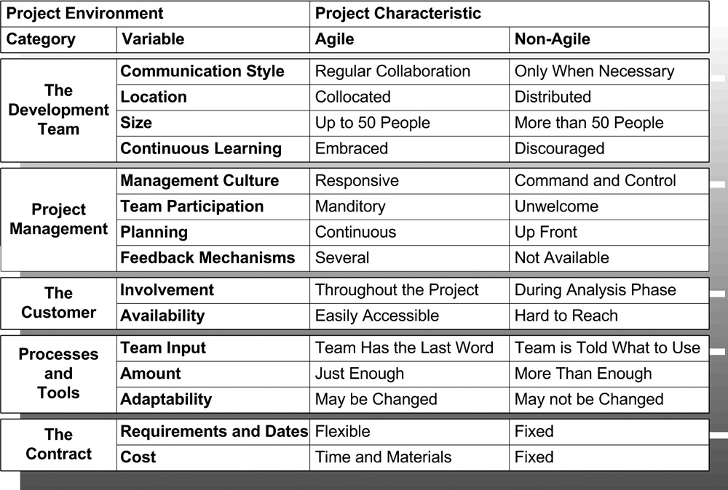
Figure 2.1: Project characteristics—agile versus non-agile.

THE DEVELOPMENT TEAM
The agile methodologies require teams of individuals who openly communicate and collaborate and who are committed to continuous learning. They also are geared toward teams of up to 50 individuals who work either alongside or within close proximity to one another (although specific methodologies such as Scrum, FDD, and DSDM can scale to larger project team sizes).
A successful agile project is one staffed with programmers who like to work with others, not programmers who like to work alone behind a closed door. Agile focuses on communication both within the team and between the team and its customer. Communication within the team is a no-brainer—a team cannot work effectively if its individual members do not raise issues, provide feedback to one another, and strive to resolve different points of view. When it comes to communicating with the customer, programmers need to be the sort of people who are willing to start conversations, raise questions, and discuss options—instead of guessing—when they encounter the empty spaces between requirements.
Collaboration is essential to share knowledge of the code base and to identify and implement optimal solutions. It is achievable by promoting a culture in which a programmer is given the time and encouragement to grab the guy next to him and strike up an impromptu design discussion or call over another team member to pair program with through an unfamiliar or technically tricky patch of code.
Furthermore, the agile methodologies want individuals who are open to and take enjoyment in learning new things, individuals who are naturally inquisitive and willing to adapt to changing situations. Such individuals will make the most of agile methodologies and practices by implementing, tailoring, and switching them to meet shifting requirements, technologies, and project environments.
Finally, team size and collocation are important because of many of the other characteristics of agile development. Smaller groups that work within the same physical space require fewer lines of communications, can operate on less-formal processes, can come to agreement more easily, and can adapt to change more rapidly. A larger or distributed team may take a significant hit on productivity because more time is spent on communication and coordination activities than would be required—proportionally—to steer a smaller, collocated team. As noted earlier, team size does vary by methodology, and larger teams are not unheard of. FDD took its maiden voyage on a 50-person project and can handle larger teams. Scrum also has a history of running larger teams. Similarly, projects with distributed teams have executed successfully following a variety of agile methodologies. However, all these cases demand a greater degree of skill, diligence, and expertise in implementing agile development.

Project Management
Agile teams require a management structure that is responsive to the needs of the team, over which the team has some influence, and that provides mechanisms for regular feedback to evaluate progress and processes.
Agile development all but requires an environment in which project management is receptive to the needs of the team and their desire to employ an agile methodology. Most management-related agile practices (such as short iterations, small releases, and the maintenance of a sustainable pace) cannot be implemented without the consent and cooperation of project management. At the extreme, even many development practices (such as testing and refactoring) cannot be followed if a project’s management does not value those practices and is too much of a miser to allow programmers to allocate their own time.
Agile methodologies vary over how much control a team needs to have in its own management, although all agree that the team should have at least a hand in making decisions. XP, for example, calls for teams where each programmer communicates directly with the customer as needed, and the team is overseen by a coach who is also a programmer. In this textbook implementation of XP, there may be no need for a project manager, and the team can be entirely self managed. Crystal, on the other hand, allows for teams that vary in structure from self-management to heavy process, depending on the size and criticality of the project. In general, Agilists agree that it becomes very difficult for a team to remain agile if management refuses to listen and respond to the needs of the team.
Finally, agile development requires feedback mechanisms so that the team can regularly evaluate whether it and its practices are on target. Agile teams need to collect and evaluate both verbal and metrics-related feedback in order to measure overall progress, to determine whether specific practices are working, to identify when something stops working, and to respond to change in either requirements or environment. A good example of a management-related structure that facilitates useful feedback is the practice of short iterations, which provides a regular interval for gauging progress and collecting metrics. While typical project plans demonstrate whether the team is ahead of or behind schedule, consecutive iterations can depict whether a team is growing more productive (and catching up to schedule) or slowing down (and losing its ahead-of-schedule cushion). Meanwhile, metrics collected over consecutive iterations, such as the number of unit tests written or the number of defects uncovered, can be used to measure whether newly implemented or tweaked processes are adding value to the team.
Agile management concepts are addressed specifically in Chapter 10, “Agile Management.” Activities related to managing agile projects are discussed throughout this text but are concentrated in the second half of the book.

The Customer
Agile development requires a customer who is involved throughout the lifecycle of the project and is easily accessible to team members. The customer does not need to be a single person, but the customer must be one or more individuals who are familiar with the project, are empowered to make functionality related decisions, can speak with a single voice, and, ideally, have a vested interest in the outcome of the project.
Agile methodologies want customer involvement throughout the entire project for both practical and agile reasons. First, speaking practically, it is simply common sense that any project will deliver a better product when it has a knowledgeable and interested individual on call to provide input and direction. Second, continuous customer involvement is required by the just-in-time nature of many agile management practices. More specifically, small releases and short iterations—which spread planning and requirement decisions across the lifetime of the project—require the regular engagement and participation of the customer.
Different methodologies request different levels of customer availability, ranging from daily access to an individual who sits with and works alongside the team. Regardless of methodology, the goal is the same. An easily accessible and communicative customer means requirements can be refined when the majority of questions arise: during low-level design and coding.
Typically, a customer cannot merely be assigned to an agile team and be expected to provide the team with what it needs. Agile teams need to take the time necessary to acquaint a customer with an agile approach and ensure he is comfortable with defining, explaining, and planning new bits of functionality on a regular basis. These topics are discussed in depth in Chapter 15, “The Customer.”

Processes and Tools
Development processes and tools should be agreed to by the team and should be of the “just-enough” variety. That is, the team should employ those processes and tools that provide sufficient checks and structure to keep it disciplined and on target, but nothing more. For example, a team might choose to use a source control tool because of the obvious perils that arise from not having an identified gold standard for the state of the code at any give time. Or, a team might commit itself to checking code several times a day because each programmer wants to avoid the time that would otherwise and inevitably be lost if code were left on individual workstations to grow in disparate directions over several days.
Any process or tool that is not accepted by the team or that goes beyond providing just enough structure for the team is unnecessary baggage. Whenever possible, agile methodologies seek to pitch this baggage back onto the platform before the train leaves the station. Satchels of documentation are often the first thing programmers ditch. Project plans that spell out packet-by-packet how the work will be performed but have no basis in reality quickly follow. Sometimes the team clears out the train and starts rolling down the track. Too often, however, the customer (or the testing team or the database administrator) is right there on the platform tossing, smuggling, or otherwise trying to get some of that baggage back onto the train.
In my experience, most of the teams that make the effort have managed to strike some form of compromise with the relevant parties, where some of the heaviest tools, processes, and trunks get booted from the train, and some of the baggage the customer really wants stays on. The customer may have good reason to ask for some of these things. In a multisystem environment, other projects may require artifacts that the team itself does not find useful. In large companies, the customer may not have the authority to permit the team to shirk a given process or not use a specific tool.
Of course, there is a point at which so much process and so many tool requirements get thrust on an otherwise agile team that it begins to feel downright unagile. Been there. Done that. At some point, if the train cars fill up with enough baggage that the programmers and manager cannot remove, an agile team may need to follow tracks that do not align with any named methodology.
Implementing and remaining agile in heavy process environments will be discussed in Chapter 20, “Real-World Environments.”

The Contract
Possibly because agile development is so focused on accepting and being prepared for change, sometimes it seems to have a little problem with commitment. Specifically, this is a commitment to cost, requirements, and timeline. The agile methodologies are shy on these topics for two reasons. First is change itself. Agile projects thrive in environments where change is the norm. In fact, one of agile’s best selling points is that it allows and even encourages customers to change their minds about requirements late in the project. Since requirement changes are typically thought to have an effect on both price and timelines, one can begin to appreciate Agilists’ reluctance to enter into such rigid contracts.
Second, contracts with hard numbers and dates can encourage both vendor and client to focus on the wrong thing—namely, the contract. Agilists note that these parties can readily lose track of the spirit of the contract by focusing on its letter. In the face of a changing business climate for the client, the vendor may grow focused on delivering the functionality spelled out in the contract. In spite of flexibility and a willingness to adjust to change on the part of the vendor, the client may refuse to budge from the contract price. Either scenario, Agilists would argue, sticks one of the parties with the short end of the stick and will discolor future engagements.
The use of contracts in agile development, including those based on fixed-cost engagements, is discussed more in Chapter 20.

AGILE PRACTICES, NON-AGILE VALUES
A development team does not become agile merely by adopting a set of practices and policies. Agile development is really a mindset [Cockburn02]. To be truly agile, a project and the individuals who oversee and regularly interact with it must subscribe to the values and principals laid out in Chapter 1, “Agile Development Primer,” and re-examined here. That is, to be truly agile, a project culture must trust its people, foster communication and collaboration, value the ability to respond to change, and never forget that the goal of the project is to deliver software that is useful to the customer.
On real-world projects, it is sometimes impossible to get an entire team to shift over to an agile value set, much less the customer, stakeholders, or directors who oversee the project. For example, consider a single project of eight people, embedded in the IT department of a Fortune 500 company that is pursuing CMM Level 3 certification and already has in place a waterfall process with a strict regiment of end-of-phase tollgates to ensure that analysis is completed before design, design before build, and so on. This project could not successfully turn a sufficient number of related parties (information managers, architects, users, stakeholders) to an agile mindset. By trying, it would prove an old Japanese proverb: The nail that sticks up gets hammered down.
Ultimately, a project is not agile if its culture does not support agile values. Such a project, however, may still benefit from adopting agile practices.

WHAT PROJECTS CAN BENEFIT FROM AGILE DEVELOPMENT?
Almost any project can benefit from agile development to some degree. Failure to meet one or more of the characteristics discussed in this chapter is not a deal breaker for teams that want to go agile. Failure to meet certain characteristics can rule out the use of one or more named methodologies. Failure to satisfy any characteristic in a single category (from those listed in Figure 2.1) will probably rule out the strict adherence to a named methodology, but a named methodology may certainly (and probably should) be employed as a guide for a project that chooses to pursue agile development. None of these outcomes is necessarily bad. A team can still adhere to agile values under these circumstances.
A failure to meet a majority of the agile characteristics described in this chapter can pose real challenges for a project that wishes to go agile. Any team in this situation has two options available to it. First, the project may endeavor to change its environment. Depending on the specifics of a project, this may involve making an appeal to the project stakeholders, initiating a discussion with a higher level of management, or attempting to alter the project’s relationship with its customer. While none of these actions sounds particularly appealing, adjusting the project’s environment to a more agile mindset and foundation will be in the long-term interests of the project.
Second, the project may chose to implement agile practices on a gradual and opportunistic basis. If a project team cannot change its environment, then that project really cannot call itself agile. But what is in a name? There is nothing to stop the team from slowly, determinedly, and cautiously adopting agile practices. Automating the build, implementing a unit test framework, organizing requirements into features, and executing task cycles are all activities that any team may be able to adopt, and there are others. Perhaps the team is not adopting agile practices but instead best practices that happen to have been thoroughly investigated and embraced by the agile methodologies. Still, there is no qualitative difference.
Most any project can benefit from adopting even a single agile practice, but here is the caveat: That single practice must be correctly chosen, embraced by the team, given the appropriate time to take hold, and adhered to. There is no guarantee, but if the first practice does not take hold, there should be nothing to stop a project team from trying again. Still, a team that slowly and successfully adopts one practice after another may see those once rigid environmental constraints crumbling away until it finds itself in a place that it can truly call agile.
The correct application of agile practices and adherence to agile values can bring tremendous results in a wide variety of environments. My experience has included successful projects in a selection of markedly non-agile environments. Operating in such environments can, however, make implementing agile practice more difficult, reduce the productivity of a team, threaten morale, and significantly slope up the agile learning curve. Whenever possible, it is best to make the project environment more agile, but of course there are perils to that, as well. We will pick up the discussion of altering your project environment in Chapter 5, “Going Agile.”

STARTING MONDAY: ASSESSING YOUR PROJECT ENVIRONMENT
After reading this chapter, you may want to determine just how agile your project environment is. This activity may help in selecting which agile path your project will embark upon, and the information you collect can feed directly into the topics discussed and questions raised in Chapter 5 and Chapter 6, “Agile Practices.” Figure 2.2 provides a checklist that you may use to complete this assessment.
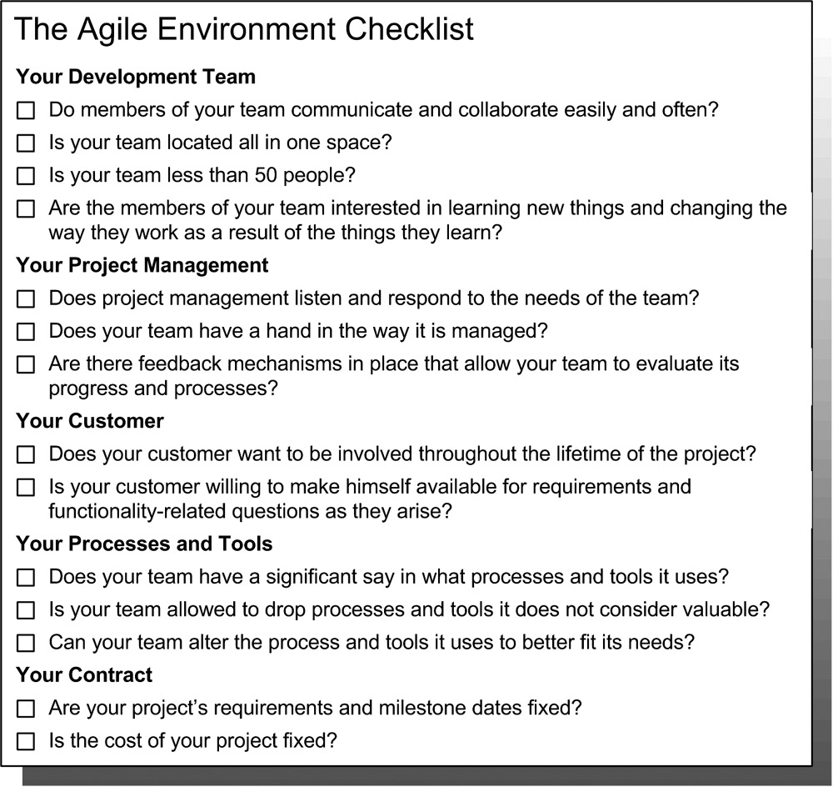
Figure 2.2: Assessing your project environment.
This is not an exhaustive list of criteria, nor does it take into account the specific aspects of particular methodologies. DSDM, for example, has a more detailed list of questions known as a Suitability/Risk List [Stapleton03]. This list should, however, provide a team lead or project manager with a sufficient amount of input to guide the selection of an agile methodology (when reading Chapter 3, “The Agile Methodologies”) and determine whether (and how) the project will strike a balance between an agile approach and a more traditional approach to software development.
One cautionary note: Do not make a big to-do out of this exercise. Rather, it is something you might complete on your own or share with one or two trusted members of the team. In short, keep a low profile. For reasons discussed later in the book, it is often best not to draw undue attention to your project when going agile.

Chapter 3: The Agile Methodologies
The agile methodologies are as similar as they are different. The goal of this chapter is to provide the reader with a feel for each methodology so as to determine whether one or more of them is a good fit for a project or organization.

COMMON THEMES
So as to avoid repetition, themes common to all the agile methodologies have been left out of the descriptions. So that they are not overlooked completely, those common themes are listed here.
- Agile teams focus on completing features as opposed to simply checking off tasks.
- Agile teams attempt to work with change instead of preventing it.
- Documentation is secondary to working functionality.
- Timeboxing is not used to make people work harder but to ensure that tough decisions are not deferred and that the most important bits of work are prioritized accordingly.
- Planning and estimation are team activities and should not be performed by a lone project manager.
- Feedback collected near the end of the project arrives too late to be of any use to the project. Feedback should be elicited regularly so that the team can make adjustments during the project. Short iterations provide an excellent mechanism for feedback loops.
- Projects must be able to adjust their direction as the result of internal feedback and external events.
- Agile development is not about reusing techniques that work in every situation. It is about creating a project environment and culture that allow skilled professionals to adapt to changing requirements and situations.
- While process is a necessary component of software development, an over-specified process slows down a project.
- No amount of process can replace good people.
These points are not meant to reiterate the agile values or principles listed in Chapter 1, “Agile Development Primer,” though in some cases one or more may be restated in plainer English.

METHODOLOGY DESCRIPTIONS
Each methodology is described in depth in the pages that follow. As much as possible, the descriptions of the methodologies are both thorough and consistent. For the sake of consistency, each methodology description should include the following information when available:
- The methodology’s approach to management and programming activity
- How the methodology fosters a culture of communication and collaboration
- The methodology’s conception of an iterative project flow
- The methodology’s tolerance for diverse project environments
The most visible indication of this approach is in the process diagrams for each methodology. Each diagram has been built from the same toolkit of circles, boxes, and arrows, and the more commonly recognized process diagrams for some methodologies such as Scrum, FDD, and DSDM have not been included. This is intended to make the process diagrams more readily comparable across methodologies.
Finally, the exception to this unified description approach is Lean Software Development, which is not a methodology in the same sense as the other six.

EXTREME PROGRAMMING (XP)
The best-known and most widely used agile methodology is extreme programming (XP). It is also the only agile methodology that focuses primarily on the programming side of software development.
The impact of XP has been significant and far reaching. Many of the practices that XP has embraced and fostered are regularly adopted by agile and even non-agile teams. Several of those practices will be discussed in the book as agile practices. Furthermore, the XP community continues to develop, explore, and refine software development practices that can benefit a wide variety of teams.

Programmer-Centric, Test-Infected
One often gets the impression that every person on an XP team is a programmer. This is not far from the truth. Even the management roles on an XP team (the coach and the tracker) are meant to be held by individuals who also complete programming tasks. While XP teams typically can and do incorporate dedicated managers, analysts, and testers into their ranks, there is no position on an XP team that cannot be filled by a programmer (and that includes the job of the customer) [Jeffries00]. This is, in fact, a strength of XP. By making programmers responsible for their own analysis and management, XP cuts out many of the levels of (and barriers to) communication associated with traditional development processes. There are no walls that project plans, requirement documents, or hand grenades can be thrown over. Since they will be stuck with the plans they draft, XP teams tend to be more responsible with the system they build and realistic with the goals they set.
Additionally, XP is unique among the agile methodologies because of its laser-like focus on testing [Fowler03]. Although the other agile methodologies recognize testing as an important component of software development, XP is the only methodology to prescribe how testing should be fit into the development process. XP could not be implemented without testing. Furthermore, many XP-inspired agile practices (such as continuous integration, simple design, and refactoring) are of little use and potentially dangerous to teams that have not embraced testing.

Four Values, Twelve Practices
XP is founded on four values: communication, simplicity, feedback, and courage. These values are meant to guide the decisions and actions of an XP team. Set firmly atop those four values are the 12 practices of XP. The 12 practices are the muscle of the methodology. They stipulate how the team goes about its daily programming and planning activities. When strictly followed by a group of skilled and motivated programmers, they lead to a high-discipline, low-defect, results-oriented and effective project team.
XP’s 12 practices have shifted slightly over time (and may continue to do so). Such change is merely indicative of a healthy, evolving, and relevant methodology. At present, the 12 practices (in no particular order) are as follows [Wiki04]:
Test-driven development: The practice of writing unit tests prior to writing code, which serves to aid the design and development process. Discussed as an agile practice in Chapter 8, “Testing.”
Planning game: A set of rules and moves that may be used to simplify the release planning process. Discussed as an agile practice in Chapter 13, “Small Releases.”
Whole team: The programming team, management, the customer, and all other pertinent parties work within the same open workspace to get the project done [Martin02]. This practice is the evolution of two former XP practices: onsite customer and collocated team. Onsite customer is discussed as an agile practice in Chapter 15, “The Customer,” and collocated team is discussed as an agile practice in Chapter 17, “Communication and Collaboration.”
Pair programming: Two programmers working at one workstation can actually produce better quality code without costing extra time over the life of the project. Discussed as an agile practice in Chapter 7, “Design and Programming.”
Continuous integration: If each programmer checks in working code several times a day, the system should never be far from a production state. Discussed as an agile practice in Chapter 7.
Design improvement: The team needs to keep the code clean by regularly taking the opportunity to clean and simplify complicated or confusing sections. This practice was once referred to as refactoring, which is discussed as an agile practice in Chapter 7.
Small releases: Chapter 13 and Chapter 14, “Executing Iterative Development,” discuss this common agile approach in depth.
Simple design: Programmers must design and code a system that works today, not one that may be needed in the future, because budgets, business conditions, and all manner of things can cause the future to change. Discussed as an agile practice in Chapter 7.
Metaphor: The project team should write and keep a simple statement that says what the system does and how it does it. This metaphor ensures that the entire team shares a common vision of the system. Discussed in Chapter 12, “Project Initiation.”
Collective code ownership: The whole team owns the code for the entire system. Therefore, each programmer may work in whatever part of the code he needs to in order to complete a new feature or otherwise improve the system. Discussed in Chapter 7.
Coding standard: A common coding standard used by the entire team ensures that the code is easily understood and accessible by any programmer.
Sustainable pace: Teams that work too hard burn out, and projects with burned-out teams fail. Sustainable pace focuses on keeping team members working when they are in good shape and letting them stop when they are tired. This practice was once called the 40-hour workweek and is discussed in Chapter 10, “Agile Management.”

Highly Iterative
An XP project runs under a steady percussion of one- to four-week iterations (illustrated in Figure 3.1). Just about all project activity may be stuffed into XP iterations, including the creation of user stories (the artifacts that XP uses to identify and communicate project requirements). Arguably, the only three things an XP project requires to initiate its first iteration are an iteration’s worth of user stories, a decision on the technology that will be used to complete those stories, and funding. These make XP a very handy tool for rapid prototyping and systems intended for rapidly changing business environments.
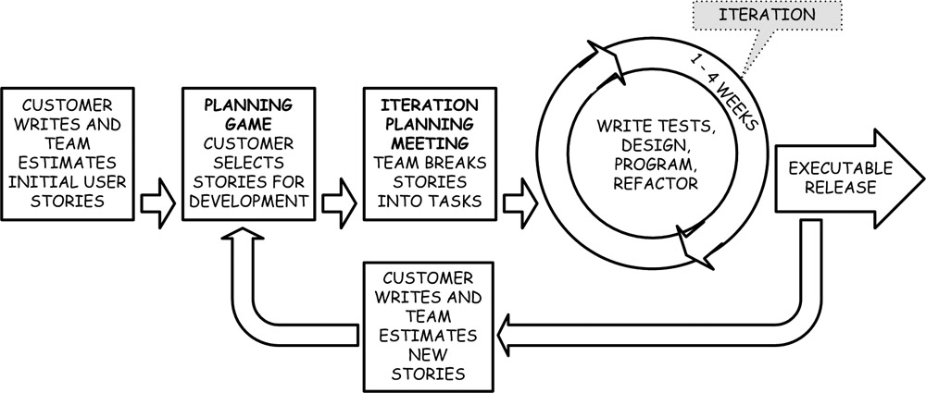
Figure 3.1: The highly iterative XP project flow.
At the end of each iteration, the team delivers a fully programmed, fully tested, production-worthy version of the system (irrespective of whether that version goes into production or on the shelf). Therefore, in XP every one- to four-week iteration may be treated as a release. In practice, because the delivery of a new system every few weeks can be disruptive for many businesses, XP teams often will group a specific number of iterations into a release and deliver new software into production at an acceptably less frequent and consistent pace.

Small Teams, Engaged Customer
In its pure form, XP works best with smallish, collocated teams of up to a dozen programmers. There are other significant project characteristics that XP requires to be truly effective. These include:
- A knowledgeable member of the business who is assigned to and sits with the team.
- No plan that stipulates the delivery of specific functionality on a specific date.
- A minimal level of documentation.
- An open workspace (discussed in Chapter 17).
XP teams can and do manage to adjust when one or two of these project characteristics are out of whack, but a pure implementation of XP can bend only so far. Ultimately, a project team operating within an environment that does not conform to the majority of these characteristics will implement something less than pure XP.

See Also
- Browse over to Don Wells’s “Extreme Programming: A Gentle Introduction” at http://www.extremeprogramming.org.
- Ron Jeffries also hosts a good site at http://www.xprogramming.com.
- The entire XP series, starting with Kent Beck’s Extreme Programming Explained: Embrace Change [Beck99].
- ObjectMentor (at www.objectmentor.com) provides good-quality and well-respected XP training courses.

SCRUM
Scrum is a management-focused agile methodology that is relatively straightforward and can be enacted in a wide variety of project environments. The methodology provides the guidance necessary to direct a project in an environment of high changeability and where different parties within the customer may have conflicting or competing interests. Scrum is rather light on the programming side of things. While it does stipulate that the team deliver tested and working functionality, it does not prescribe how the team should go about achieving this goal.
The values upon which the Scrum methodology rests are commitment, focus, openness, respect, and courage.

Empirical Process Control
Scrum is founded on the concept of empirical process control. This concept is a contrast to defined process control, where the production process for a product is defined and refined to meet an acceptable convergence of cost and quality. The complexity and unpredictability of a software development project (in terms of requirements, goals, technologies, and the general business climate) often render the use of a defined process impractical. This is where Scrum enters the game. Through the use of empirical process control, users of the methodology control quality and cost by [Schwaber04]:
- Making the aspects of the development process that most affect the project’s outcome visible to the customer.
- Allowing the customer to inspect the product regularly and ensure little variance from stated objectives.
- If an inspection shows a variation beyond acceptable limits, enabling the customer to quickly adapt the development process or product.
In Scrum, empirical process control is used to steer both day-to-day and iteration-to-iteration activity.

Self-Managed Team, Scrum Master, Product Owner, and Everyone Else
Scrum makes a clear distinction between the team whose responsibility it is to deliver the project (programmers, testers, analysts, and technical writers) and everyone else (stakeholders, business users, and upper management). While the latter party selects the system’s features and gets a regular view into the team’s activity, the programmers perform the day-to-day management necessary to build the system. Even more than XP, Scrum puts the project team’s success or failure in its own hands. While the customer has a clear and daily view into the activity of the team and is expected to exert control on the project at the outset of each 30-day sprint (an iteration in Scrum), the customer is not allowed to interfere with the team’s activity at any time during the sprint. While in a sprint, the team is given the time, clearance, and trust necessary to make the right decisions and complete its work. The customer then has the opportunity to address any issues that may have arisen during the sprint prior to or at the onset of the next sprint.
The project team is led by a Scrum master (this may be the team lead or project manager). This individual bridges the gap between the project team and the customer and ensures that both groups are adhering to the rules and values of Scrum [Schwaber04].
Scrum recognizes that there may be lots of individuals related to a project (stakeholders and customers) with competing interests, worries, and needs, but Scrum designates a single individual, the product owner, to tell the team what it will develop at the beginning of each sprint. It is the job of the product owner (who may be a product or project manager in real life) to communicate and negotiate with the project’s variety of stakeholders and interested parties and prioritize the product backlog, which contains an evolving list of functional and technical features for the system under development. In Scrum, the product owner must be a single individual (and not a group or committee).

Timeboxed and Sprint Driven
Timeboxing is an important feature of the 30-day sprint. This forces tough decisions about functionality and design. The more things different customers request at once, the longer it will take for the project to produce anything of value; meanwhile, there is always a more elegant design solution if the programmers would keep looking. The timeboxed sprint keeps the team from entering into such low-productivity quagmires by forcing the customers to agree on the features the team will produce in the next 30 days and by giving the team a hard deadline to deliver as much of those features as possible.
Scrum uses the daily Scrum meeting, which facilitates daily communication from the programmers on the project to the otherwise unengaged stakeholders. This meeting (discussed as an agile practice in Chapter 17) ensures that the team communicates frequently, that no one ever wanders far off course, and that customers are made aware of roadblocks in a timely manner. Figure 3.2 illustrates this process.
Each sprint ends with a product increment that demonstrably furthers the progress of the project, whether it is a release into production, a substantial and usable step forward in functionality, or the proofing of a particularly risky component. It is important to note that this sprint goal is not fixed in stone. It may be moved by agreement of the team and its product owner if the team appears to be ahead of or behind schedule.

Little Assembly Required and Scalable
Of all the agile methodologies, Scrum is probably the one that can be established—without customization—in the widest variety of environments. This stems from its lightweight management processes and lack of specific programmer policies. This lightweight nature means that Scrum can wrapper existing programming practices, usually without significant changes to the way the team does its daily work. Scrum does, nonetheless, make some real demands on the customer. Mainly, Scrum requires that the customer not meddle with the team while in sprint and accept that the team may alter sprint goals as required by the difficulty or ease of its tasks.
Scrum out-of-the-box is formulated for smaller teams. However, it comes packaged with a scaling strategy, based on a Scrum of Scrums, that is claimed to have been applied to an 800-person project [Cohn04]. This approach will be discussed in Chapter 20, “Real-World Environments.”

See Also
- Up-to-date information on Scrum and Scrum master certification can be found at http://www.controlchaos.com.
- Agile Software Development with Scrum by Ken Schwaber and Mike Beedle [Schwaber01].
- Agile Project Management with Scrum by Ken Schwaber [Schwaber04].
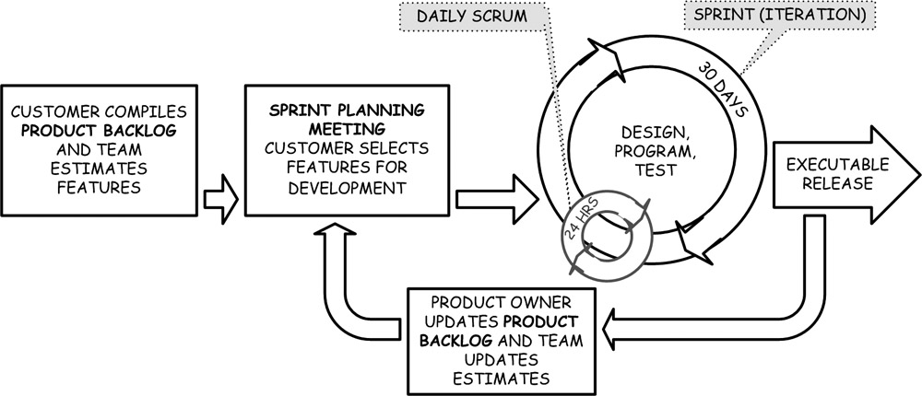
Figure 3.2: The sprint-driven Scrum project flow.

FEATURE-DRIVEN DEVELOPMENT (FDD)
Feature-Driven Development (FDD) tackles both management and programming activity, and it does it with scale, having clocked in a 250-person, 18-month project [Highsmith02]. In order to scale to this extreme, FDD calls for system-wide modeling activity at the outset of the project. This, combined with a penchant for providing an initial (but flexible) plan up front, has caused some to criticize FDD as not being very agile [Boehm04]. This is an unfair criticism. An FDD project is highly iterative, performs low-level analysis and design activities in the same iteration that it completes functionality, engages its customer through the entire lifecycle of the project, and is tuned to recognize and respond to change.
Nonetheless, FDD does celebrate its divergent opinions from some other mainstream agile methodologies. In particular, it values design-first activity, provides its customer with an upfront plan, and mandates that programmers own specific parts of the code [DeLuca04]. Of course, there are more than a few customers who might find such sentiments appealing.

Eight Best Practices
A successful implementation of FDD is founded upon eight best practices. As with XP’s 12 practices, teams may gain some benefit from adopting one or more FDD best practices, but the practices are built to reinforce one another, and their full benefit can be obtained only when all eight are being followed. The eight best practices of FDD are [Palmer02]:
Domain object modeling: The domain model is an overall roadmap of the system to be built. It consists of a handful of high-level diagrams that depict the relationship between classes and sequence diagrams that demonstrate behavior. This approach is discussed more in Chapter 12.
Develop by feature: This is a premise common to all the agile methodologies (and a cornerstone of agile development). Features are discussed in Chapter 11, “Features and User Stories,” and iterative development is discussed in Chapter 14.
Class ownership: The code class is an encapsulation mechanism that is common among object-oriented programming languages. Class ownership is the enactment of code ownership, where each class within a system is assigned to a specific programmer. It is the opposite of XP’s collective ownership.
Feature teams: This practice is founded on the strict application of class ownership. The method is employed by class owners to complete features that span multiple classes. Since features commonly involve more than one class, feature teams are the common approach to design and development in FDD. Feature teams are discussed as an agile practice in Chapter 7.
Inspections: Inspections that focus on the identification of defects and do not intimidate or humiliate the programmer can significantly increase the quality of a system. Secondary benefits to inspections include improved transfer of knowledge and greater conformance to coding and design standards.
Regular build schedule: Teams need to build the complete system at regular intervals to identify integration errors early and so that an up-to-date and functional version of the system is always at hand (for activities such as client demos). The build may be performed hourly, daily, or even weekly, depending on the size of the project and the amount of time it takes to perform a complete system compile and integration. This practice is similar to the automated build agile practice, discussed in Chapter 7.
Configuration management: Code needs to be stored and versioned at a level that meets the demands of the team. Products with multiple installed and supported releases, for example, will need a much more complex versioning tool than a system that is deployed on only one server. Analysis, design, and testing artifacts also need to be versioned throughout the lifetime of the project. An audit trail of this sort is often necessary to meet legal or other business requirements.
Reporting/visibility of results: Regular and easy-to-understand updates of status are necessary to guide a project. Additionally, they keep the customer and stakeholders aware of the project’s status, so that they can plan and act accordingly. FDD’s approach to collecting and reporting status is discussed in Chapter 16, “Reviewing and Reporting Progress.”
There are six key roles on an FDD project: project manager, chief architect, development manager, chief programmers, class owners, and domain experts (users, stakeholders, analysts, and so on).

Model Initiated, Feature Driven, Reporting Minded
As illustrated in Figure 3.3, an FDD project wends its way through the following five processes:
- Develop an overall model
- Build a features list
- Plan by feature
- Design by feature (DBF)
- Build by feature (BBF)
Each process is built on an entry-task-verification-exit (ETVX) pattern. That is, project teams have specific activities that should be completed prior to entering and exiting each process.
The observant reader may note two visual effects that make the process diagram for FDD different from the diagram for the other agile methodologies discussed thus far. First, the iteration circle is drawn three times. This is meant to signify that there are multiple feature teams on an FDD project working simultaneously and not all operating on the same iterative rhythm. Instead, each feature team starts and completes an iteration based on the planning of its chief programmer.
Second, note the arrows and box in dots at the bottom of the diagram. An optional (but not widely advertised) option in FDD is to iterate through the entire five processes (as opposed to the last two) on a less frequent basis. This approach may allow a project team to employ FDD within the more common small-releases, short-iterations approach taken by the other agile methodologies.
FDD keeps a thumb on the pulse of the project at all times. It tracks and reports progress by rolling up metrics based on the status of each individual feature through a low-overhead reporting approach that provides both feature-level progress tracking and executive-level project overviews (see Chapter 16). FDD highly values the ability to know the state of the project at any given time. When new or changing requirements cause a significant change in the overall schedule of the project, the project manager on an FDD project will go to upper management, exhibit and explain the deviations, and request a change in scope or schedule.
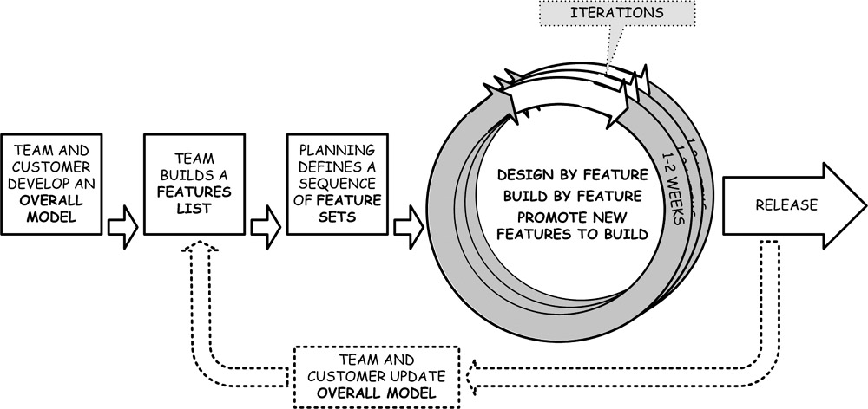
Figure 3.3: The design-first FDD project flow.

Frontload Some Architecture and Planning
This is where an FDD project takes shape. The first three FDD processes are performed only once in their entirety. However, projects return to these activities if the amount or timing of work changes significantly.
In the first process, the team works with the customer to produce an overall model of the system. The model is meant only to be completed to the “shapes” that will make up the system and is intended to force individual ideas and assumptions out into the open at the beginning of the project. The approach resolves misunderstandings early and ensures that the entire team has a more complete conception of the system. FDD also believes that some upfront work for the domain model will lead to better initial designs and reduce the need for future refactoring [Palmer03].
In the second process, the project’s management uses the overall model to produce a features list. The system is broken down into features (bits of functionality that are each useful to the customer) and grouped into feature sets. On larger projects, feature sets are grouped into a hierarchy of feature sets. The feature sets are prioritized, and a minimally complete system is identified (this being the minimum features required for the system to be valuable to the customer) [Coad99].
In the third process, the project schedule is fleshed out in the form of a sequence of feature sets. Each feature set is planned for completion in a specific month (FDD does not give exact dates). Chief programmers meet to divvy up ownership of the different feature sets. At this point, all programmers on the project team are assigned to specific classes identified in the overall model.

Design and Build by Feature
The completion of each feature set takes place over one or more iterations of DDF and DBF activities (with each iteration lasting no more than one to two weeks). Each chief programmer works through his list of feature sets, creating a new feature team for each feature set, which is constituted by gathering together the owners of the classes related to the features in the feature set. The feature set is then completed with the guidance of a chief programmer (feature teams are discussed as an agile practice in Chapter 7). Feature sets are refined with the assistance of a domain expert, designed as part of a group activity, built and unit tested, reviewed by the feature team, and then integrated into the system.
It is worth noting that, although FDD does call for specific high- and mid-level programming activities, such as reinforcing an object-oriented design, mandating unit testing, and requiring design sessions and code reviews, it still does not step down to the low-level prescriptions (such as TDD and pair programming) associated with XP. Decisions regarding such low-level programming activity are left to the discretion of individual project teams.

Scalable, Prefabricated Approach
FDD lends itself to an approach that is more structured and design forward than other agile methodologies, while still enabling a streamlined management process founded on agile foundations such as short iterations, customer involvement, and testing. Teams operating in an environment where upfront design is required or highly valued might find FDD to be the right approach to blend agile developments with their existing development process. Larger projects that must follow an established and proven process or projects required to provide upfront (but still malleable) schedules may also find some real value in FDD.

See Also
- Peter Coad keeps a digital copy of the original FDD write-up (see Chapter 6 of Java Modeling in Color with UML) on his Web site at http://www.pcoad.com/download/bookpdfs/jmcuch06.pdf [Coad99].
- Stephen Palmer and John Felsing’s A Practical Guide to Feature-Driven Development [Palmer02].
- The FDD discussion forum site at www.featuredrivendevelopment.com.
- Jeff DeLuca’s FDD Web site at www.nebulon.com/fdd.
- David Anderson’s www.agilemanagement.net has several good articles and blog entries about FDD.

THE CRYSTAL METHODOLOGIES
Crystal is based on the idea that different projects need different sorts of methodologies. The Crystal family is a set of methodologies that all share the same principles and building blocks, with each individual methodology geared toward a different project situation. Crystal should not be confused with a toolkit approach, such as the one employed by the Rational Unified Process (RUP), which provides a development kit of processes, practices, and documents that is meant to be tailored for each project. Instead, the Crystal approach is to collect and catalogue sample methodologies. A project selects a base methodology from that catalogue and tailors it to its particular environment and circumstances [Cockburn01a].
The Crystal methodologies are people focused, communication-centric, and highly tolerant—described by one agile practitioner as “the least dogmatic process conceivable” [Marick04]. Nonetheless, there are two restrictions on all the Crystal methodologies: they do not currently address life-critical systems, and they are based on collocated teams [Cockburn01a]. The three properties that are central to every Crystal methodology are frequent delivery, close communication, and reflective improvement [Cockburn04].

Project Size and Criticality
Crystal catalogs its methodologies by project size and criticality, as illustrated in Figure 3.4. In the catalog, project size is denoted by color (clear, yellow, orange, red, and so on) and criticality by letter (C for comfort, D for discretionary money, E for essential money). Project size is measured by the number of people on the team. Crystal recognizes that as the team gets larger, a heavier methodology is required. Criticality measures the severity of damage that may result from a defect or other error occurring in the delivered system. Criticality is therefore translated into the amount of rigor required from the methodology. A defect in the document management system for a small company may be a pain in the neck, but the worst result that may come of it is lost time and tempers (a C-level methodology will do here). Meanwhile, a defect in a financial trading system could result in the loss of significant sums of money, someone’s job, and even the entire company (an E-level methodology is required here). Currently, the Crystal methodologies are indexed by color, so each methodology discussed here (Crystal Clear and Crystal Orange) is based on a given project size and can be tuned to fit more than one level of criticality. Finally, the astute observer will notice that a catalogue of Crystal methodologies extends beyond the area described here and depicted in Figure 3.4 [Cockburn01a].
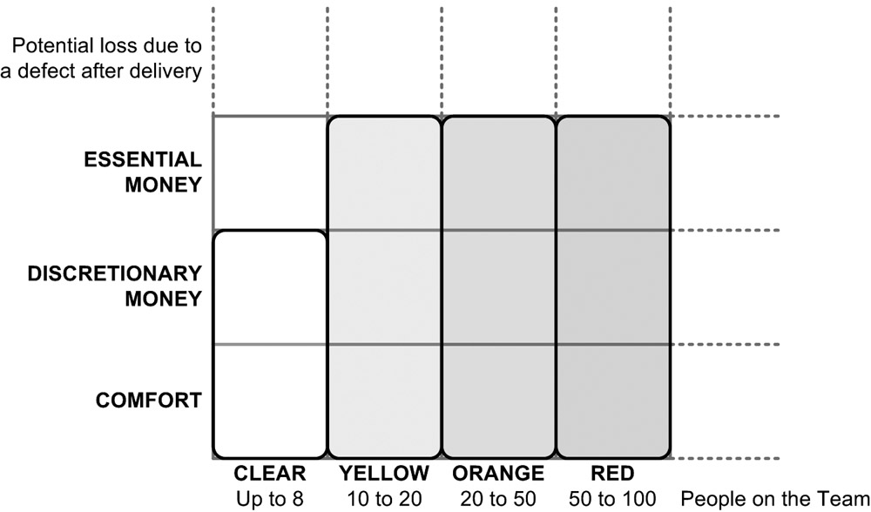
Figure 3.4: A corner in the family of Crystal methodologies [Cockburn04].

Working with Human Nature
All Crystal methodologies are based on the observation that the more disciplined a methodology is the harder it becomes to get everyone on the team to follow it. Therefore, each Crystal methodology strives to define the least disciplined process that could still succeed, maximizing the likelihood that everyone on the team will follow it. Through this approach, the Crystal methodologies explicitly trade efficiency (cost savings and time) for an increased chance of success (since more people will follow the less efficient process) [Cockburn01a].
Crystal has seven properties in total. The first three are mentioned earlier in this section (frequent delivery, close communication, and reflective improvement). The last four are personal safety (the ability to speak without fear of reprisal), focus (knowing what to do and having the time to do it), easy access to expert users, and a technical environment with automated testing, configuration management, and frequent integration. While the first three properties are mandatory to every Crystal project, the remaining four push the team further into the safety zone, the position in which the project is most likely to succeed [Cockburn04]. Each Crystal methodology is derived from the same pool of priorities, properties, principles, and sample techniques [Cockburn04]
Finally, Crystal Clear and Crystal Orange, like FDD, call for class ownership instead of collective ownership [Cockburn04]. Medium and large project teams using Crystal may want to take a look at the feature teams practice in Chapter 7 if coordinating work across classes has become an issue.

Crystal Clear
Crystal Clear is meant for a project of up to eight people on one team and working in the same area. Crystal Clear ratchets up the Crystal principle of close communication to osmotic communication, which is, in essence, a requirement that teams work together in an open workspace (see the agile practice in Chapter 17) .
Crystal Clear, like other Crystal methodologies, is focused on eliciting feedback, reflection, and tuning. Teams have a well-defined chartering period during which they define and validate the project, prior to the initiation of delivery cycles (as illustrated in Figure 3.5). During this period, the team is brought together, an Exploratory 360 is performed, the methodology is fine-tuned to the project environment, and an initial project plan is created. Crystal Clear projects must complete at least two delivery cycles and release functionality at least twice during the project, allowing it to gain real feedback from the customer in the middle of the project while there is still time to adjust. During each delivery cycle, the customer is entitled to view the progress of the system at least twice. Finally, reflection workshops are used to tune the current and future projects [Cockburn01a].
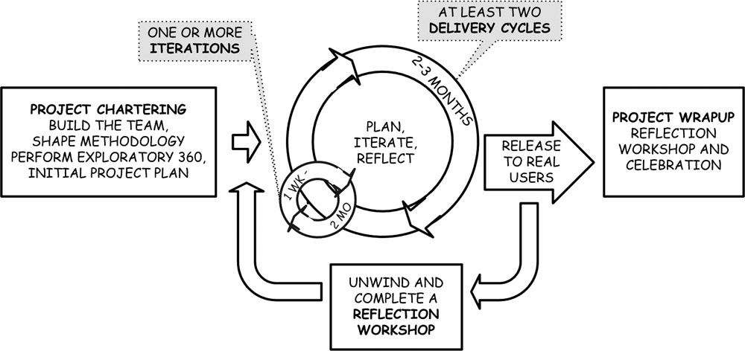
Figure 3.5: The Crystal Clear project flow, built around the delivery cycle [Cockburn04].
There are three essential roles on a Crystal Clear project: the executive sponsor, the lead designer, and the ambassador user [Cockburn04].
Crystal Clear may serve as either a fallback or stepping stone for teams that cannot currently operate under the high-discipline atmosphere of XP. It allows programmers greater flexibility in the way they perform project work. Crystal Clear teams have much greater freedom in identifying which agile practices and techniques they will employ, as long as they are in line with the overall methodology [Cockburn01a].

Crystal Orange
Cockburn originally introduced the Crystal Orange methodology in 1997, prior to all of the current hubbub over agile development [Cockburn97]. More recently, Cockburn has said he would use the methodology again, but only as a base methodology that would need to be tuned to a new project, since technologies, work products, and needs for interaction have shifted over the last several years [Cockburn01a]. The methodology is discussed here as a base methodology that one might investigate further and to illustrate how two methodologies like Crystal Clear and Crystal Orange may draw from the same building blocks to fit two significantly different project environments.
Crystal Orange was designed for projects where both cost and time to market are important, that involve from 20 to 50 people, and will run one to two years. It can be used for projects where discretionary money is at risk and may be extended to suit projects associated with essential money by adding additional verification-testing activities. Because of the larger project size, Crystal Orange provides 14 roles that individual team members may take (eight more than Crystal Clear), focuses on creation and makeup of subteams, and places additional emphasis on documentation (including the addition of requirements and user-interface documentation) [Cockburn01a].
Crystal Orange follows a similar project flow to Crystal Clear (as illustrated in Figure 3.5), but the length of a delivery cycle may be extended up to four months. The longer delivery cycle is meant to balance between complete releases that are production worthy and extensible and flexible requirements [Cockburn01a]. Crystal Orange also calls for three “deep” iterations in each delivery cycle, where the user has time to examine and give feedback on either a mocked-up or functioning system. Each delivery cycle may contain an additional number of “shallow” iterations [Cockburn97].
Finally, the methodology has an offshoot, Crystal Orange Web, that—as opposed to addressing a single project—takes on a steady stream of initiatives [Cockburn01a].

Just Enough Process and Very Flexible
The every-project-is-unique mindset that is built into the Crystal methodologies should make them amenable to a wide variety of individuals and environments. The methodologies are immediately useable but highly configurable by the fact that they come with specific policies and processes but readily allow the substitution of other, equivalent policies and processes [Cockburn01a]. Small, collocated teams that find XP too strict and Scrum too quiet on programming processes may identify Crystal Clear as just the right thing. Now that there is an entire book devoted to Crystal Clear (listed in “See Also” later in this section), project teams may be able to easily locate all the information they need on it.
Finally, the Crystal approach may have very real appeal for an organization that is attempting to execute many diverse projects. While it may entail a significant investment, the Crystal methodologies may help to rationalize a portfolio of projects by providing a set of base methodologies that provide just enough process across the organization.

See Also
- The Crystal Main Foyer at http://alistair.cockburn.us/crystal/. At last view it looked a bit dated, but it also contained some new and useful information [Cockburn04].
- Alistair Cockburn’s new book, Crystal Clear [Cockburn04a], spells out this approach to agile development in a simple, insightful, and intelligent manner.
- Another Cockburn book, Agile Software Development, discusses the Crystal approach and some of the notions behind it [Cockburn01a].
- Finally, Crystal Orange is discussed in Chapter 4 of Cockburn’s Surviving Object-Oriented Projects [Cockburn97].

ADAPTIVE SOFTWARE DEVELOPMENT (ASD)
ASD is focused at the project management level and its relationship with the organization it serves. The methodology has some trappings of traditional project management, including formal project initiation and review procedures. Unlike XP and Scrum, ASD folds the planning of future iterations into an initial stage of the project. Like other agile methodologies, ASD argues that command and control is a liability in high change environments because it slows the sharing of information and impedes quick decisions. ASD envisions the project manager as someone who enables a collaborative environment, helps to identify project goals, removes obstacles, and then steps back to let results happen [Highsmith00].
An ASD project is mission focused, feature based, iterative, timeboxed, risk driven, and change tolerant.

The Adaptive Lifecycle
As illustrated in Figure 3.6, ASD follows a project flow that is broken into three phases: speculate, collaborate, and learn. While an ASD project cycles through all three phases every four to eight weeks (registering an iteration length that is longer than most other agile methodologies), portions of the speculate and learn phases also serve to bookend the project. The focus on project initiation reveals ASD’s organization-minded nature. During this activity, as well as at other periods throughout the ASD lifecycle, vital information is exchanged between the project and the organization within which it exists. This availability and sharing of information, bundled with the iterative nature of ASD, are meant to foster an environment in which the project leaders collaborate with the organization as iterations are completed to adapt the direction of the project toward the most desirable outcome.

Speculate
ASD replaces project planning with speculation. This phase is meant to help the project and its organization appreciate the uncertainty behind the system they are about to build. Speculation does not mean that planning should not be done; it just means that the planning should be understood as tenuous. This portion of an ASD lifecycle is unlike other agile methodologies that we have discussed so far in that it includes specific documentation recommendations. These documents are relatively simple and straightforward and are meant to serve as a guide and be refined throughout the life of the project. (The documents are a project charter, data sheet, and specification outline, and they will be discussed in Chapter 18, “Documentation.”)
There are five steps in the speculation phase of ASD. The first step involves gathering information, including project mission, objectives, initial size, scope, estimates, and key project risks. Second, the entire project length is determined. Third, the number and length of iterations are decided. Fourth, the objective for each iteration is identified. Finally, features are assigned to each iteration [Highsmith00].

Collaborate
This is where programming activity occurs. Each cycle must deliver something useful to the customer, but there is no requirement that the iteration deliverables be production worthy. Like Scrum, ASD does not state how programmers should go about performing technical activities.
Instead of focusing on design, build, and testing activities, ASD calls for the project manager to focus on instilling a collaborative culture across the project team. Emphasizing collaborations is seen as an effective counter to excessive individualism, is a necessary catalyst of self-organizing teams, enables high-performance teams, and encourages individuals to focus their energies on merging diverse opinions and perspectives [Highsmith00]. There is no sure procedure for fostering collaboration within a project. For smaller projects, it could entail the institution of agile practices such as collective ownership and pair programming; on larger projects, much more effort and creativity may be required [Highsmith00a]. Ultimately, most any process, practice, or parlor trick that gets individuals on the team to communicate and collaborate more effectively is fair game.
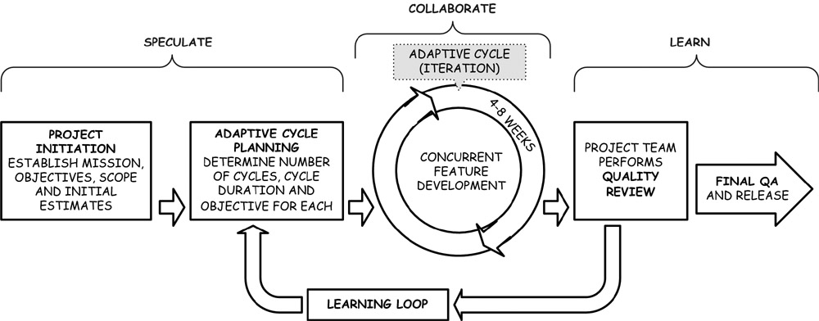
Figure 3.6: ASD’s adaptive project flow.

Learn
ASD highlights the importance of people-based feedback more than the average agile methodology. Each iteration finishes with a quality review. During the review, the project team solicits and considers all input from the customer (priority number one), the mindset of the programmers, the quality of the delivered features, and the overall status of the project. It is assumed that the result of the quality review may have an effect on the content of future iterations (even though they were planned in advance).
ASD recommends, and explores in some detail, three techniques for the learning process: focus group reviews with the customer, technical reviews of the software, and a project-wide postmortem.

Foster Collaboration Among Individuals and with the Organization
ASD lends itself to culture-based and organization-minded implementations. For example, in its speculation phase, ASD addresses organizational activity that is not discussed by other agile methodologies. These activities may provide a leaner, more agile method of constructing, evaluating, and green-lighting project-level business cases. ASD may also work well in organizations that choose to retain some of the activities of traditional project management, including formalized project definition and review processes.
It should be noted that ASD has been criticized for not providing enough specific direction to everyday teams that wish to follow it as a methodology [Boehm04]. Nonetheless, through its focus upon and insight into techniques intended to foster project-wide collaboration, ASD might also make a good complement to a more structured agile methodology. XP has been proposed as an agile methodology that ASD might complement well [Fowler03].

See Also
- Jim Highsmith, an ASD founder, has written a book on the methodology: Adaptive Software Development [Highsmith00].
- You can also browse Highsmith’s Web site at www.adaptivesd.com.
- A digital description of the methodology can be obtained at http://www.jimhighsmith.com/articles/Dinosaurs.pdf [Highsmith00a].

DYNAMIC SYSTEMS DEVELOPMENT METHOD (DSDM™)^{[1]}
DSDM advocates agile techniques similar to many of those endorsed by the methodologies previously discussed. The approach calls for a collaborate relationship between a project team and its customer, the use of timeboxing to control scope and focus on business value, and a focus on testing to ensure the quality, reliability, and maintainability of developed systems.
DSDM purports to support all parts of system development from the conception of a project idea to the retirement of the system spawned by that idea. This includes determining whether the project is a fit for DSDM and maintaining the system after the project team has been disbanded. DSDM takes the same approach to process and work products as Crystal, providing what DSDM methodologists believe to be a bare minimum of process and work products that projects can tailor to their specific technical and business environments.

The Nine Principles of DSDM
DSDM focuses on building systems in a short time, in small increments, with participation of the entire team and users, and with an explicit mindset that tradeoffs need to be made between more valuable and less valuable features. It uses the following nine principles to meet these goals:
- Active user involvement is imperative.
- The team must be empowered to make decisions.
- The focus is on frequent delivery of products.
- Fitness for business purpose is the essential criterion for acceptance of deliverables.
- Iterative and incremental development is necessary to converge on an accurate business solution.
- All changes during development are reversible.
- Requirements are baselined at a high level.
- Testing is integrated throughout the lifecycle.
- Collaboration and cooperation between all stakeholders is essential.
Similar themes reverberate between these nine principals and the values and principles of the Agile Manifesto. In fact, the DSDM principles were the starting point for the principles laid out in the Agile Manifesto. DSDM views a failure to adhere to one or more of its nine principles—without the implementation of an accepted mitigation strategy—as the introduction of a significant risk into a project [Stapelton03].
DSDM teams are typically composed of two to six people; several teams can serve together within a single project. Important roles on a DSDM team are the developer (incorporating the traditional roles of programmer, designer, and analysts), tester, technical coordinator, ambassador user, and the visionary (usually the person who initiated the project and has a vision for it). DSDM purports to address the needs of all the relevant participants in a project and spells out a total of 12 roles that individuals may take on a project.

A Seven-Phase Approach
A DSDM project wends its way through seven phases. Five of these occur during the execution of the project, and two others cover the rest of the software development phase. Three of these phases (the functional model, design and build, and implementation iterations) address the main activities within a project and are included in the process flow in Figure 3.7.
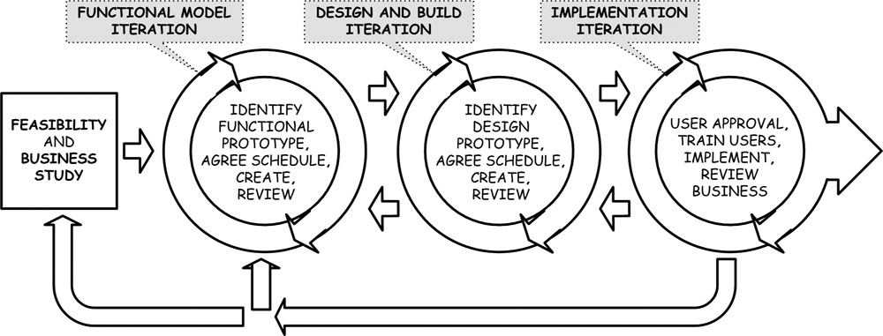
Figure 3.7: DSDM’s flexible project flow.
How a project works through these three cycles is up to the individual project. Within DSDM, a single project team may transition forward and backward between these three phases (and even back to completing new feasibility and business studies) as it pursues an iterative approach. A team may even iterate its way through each phase sequentially, although this would result in a traditional waterfall approach to the project.
DSDM schedules work within timeboxes of two to six weeks. Each of these timeboxes may contain multiple cycles of each of the iteration phases seen in Figure 3.7. DSDM uses this timeboxing approach both to ensure that tough decisions regarding functionality and technical requirements are made and to enable regular and rapid feedback.

Tried, Tested, and Enterprise Ready
DSDM has one significant downside: In order to use it, an organization must pay to become a member of the DSDM Consortium (where it also has the opportunity to influence the evolution of the methodology). This may deter small projects from dabbling in the methodology. DSDM, however, might be very interesting to medium or large organizations with enterprise systems that want to adopt a supported process with a defined set of work products and documents. Additionally, the DSDM Consortium believes its approach is well suited to work within an outsourcing environment as well as alongside a variety of other project approaches, including ISO 9000-3, CMM, RUP, and XP [Stapelton03]. With it reliance on short iterations, testing, modeling, prototyping, and forays into a variety of process environments, DSDM may deliver the right amount of agile to such an organization.

See Also
- The DSDM Consortium’s Web site at http://www.dsdm.org.
- Jennifer Stapleton’s DSDM: Business Focused Development [Stapleton03].
^{[1]}The source for the majority of the information in this section is DSDM: Business Focused Development, Second Edition and the DSDM Web site at http://www. dsdm.org [Stapleton03]. The nine principals of DSDM are reprinted with the permission of the DSDM Consortium. DSDM is a registered trademark of the DSDM Consortium.

LEAN SOFTWARE DEVELOPMENT
Lean Software Development defines the maturity of an organization by how quickly and reliably it can serve its customers. Process, documentation, and even best practices all take a back seat to the overriding goal of operational excellence [Poppendieck03a].
Lean Software Development is not a methodology in the same sense as those described earlier in this chapter. It does not propose a specific set of practices to follow nor does it subscribe to any specific process flow. Rather, Lean Software Development is a toolkit of principles, ideas that guide but that are not concrete instruction of what to do, that may be used by managers and team leads to identify, shape, and implement practices for the project team and organization [Poppendieck03].

Lean Thinking
Lean Software Development is based on the theory and principles behind lean production, which was pioneered by the once-upstart Toyota automobile company. The Toyota Production System did not take on a brute force mass production approach that was common in the day, including running machines to produce as much as possible regardless of need and always having plenty of stock waiting to be sent through the line. Instead, Toyota focused on eliminating waste in both the process and parts being used in the manufacturing system and dramatically reducing the turnaround time once an order had been placed. The approach, for example, sees inventory and raw materials that sit unused as waste, taking up space that has to be paid for. Similarly, decisions that are made earlier than necessary make a commitment to a specific direction and are expensive to undo, adding unnecessary waste.
The lean production approach swept through the American automobile industry in the 1990s. Of course, it did not stop there [Poppendieck01].

Seven Principles^{[2]}
Lean development takes lean manufacturing principles and applies them to software development. Lean development is founded on the following seven principles [Poppendieck03].

Eliminate Waste
Waste is any activity, artifact, or output that does not add value to the system. This includes documents that are not required, components that are built but then not used, any features programmed that are not immediately needed, and even the handing off of activities from one group to another. Basically, whatever slows down the project team from giving the customer what he needs is considered waste.

Amplify Learning
This principle distinguishes the development process from the production process. While the production process is focused on reducing variation, the development process is focused on defining the right product or system. Project teams need to put processes in place and shape their environments so as to amplify learning.

Decide as Late as Possible
This principle tackles environments of high and rapid change head on. Delaying decisions allows a project team to wait until the future is closer and easier to predict. Keeping options open in terms of design requirements and code enables a project team to move quickly on new and even unexpected pieces of information.

Deliver as Fast as Possible
Delivering working software quickly and as needed instead of all at once and after substantial investment and effort helps reinforce the three priciples just discussed. By focusing on delivering what is needed now, we are able to hold off on decisions about what may be needed later. Learning is amplified because early deliveries enable the customer and the team to better understand and give feedback on the portions of the system that have yet to be developed. Finally, reducing the time between a request for functionality and the delivery of that functionality also reduces waste.

Empower the Team
Decisions cannot be put off until as late as possible if they all need to be made by managers and other high-level people. When programmers are provided with appropriate guidance and engaged in activities related to design and process, they make better decisions on their own than anyone else could make for them.

Build In Integrity
Integrity means that the product or system is put together well, operates smoothly, will continue to be useful over time, can be extended, is easy to use, and is not difficult to maintain. Integrity comes from good leadership, domain knowledge, communication, and discipline, not simply good practice and process.

See the Whole
Complex systems require expertise that is both broad and deep. A common pitfall in product development is the tendency to overemphasize one’s expertise in a given area to the detriment of the entire system. A lopsided approach can be taken at the individual, project, and even organizational level because in each case the entity will want to maximize performance in its own area of specialization. The integrity of a system is based on how well its parts work together, not simply the quality of each individual part.

See Also
- Mary and Tom Poppendieck’s Web site at www.poppendieck.com contains information and articles on lean software development.
- The Poppendiecks’ book, Lean Software Development [Poppendieck03].
^{[2]}The source for the majority of the information in this section is Lean Software Development: An Agile Toolkit for Software Development Managers [Poppendieck03].

STARTING MONDAY: INVESTIGATE FURTHER
If you are inclined toward one of these methodologies, spend some time getting to know more about it. Sit for half an hour in the coffee shop of your local bookstore. Do some investigation online. Talk to someone who has done it. Do not take any one person’s word for it.
If a project team chooses to follow a strict interpretation of one of these methodologies, this book can still be of assistance. Inevitably, the team will encounter resistance when trying to roll out some practice of process. Also, no matter how much a project environment can be shaped, adjustments will need to be made to fit in the methodology.

Chapter 4: Selecting an Approach That Fits
Deciding whether to take a project team agile and then plotting the course of that team’s adoption of agile development can take significant thought and deliberation. Although it is the project team that is in the best position to contemplate and make such a decision, a number of factors that stretch well beyond the opinions of the team may bear upon the outcome.

CHOOSING BETWEEN AN AGILE AND A TRADITIONAL APPROACH
While any project may benefit from adopting one or more agile practices, it is not a given that every project would be better off by transitioning to an agile methodology.
Each of the variables depicted as sliders in Figure 4.1 may help to determine how suitable a given project is for an agile, traditional, or blended approach. These variables include two dimensions used to catalogue the Crystal methodologies (size and criticality), an additional dimensions introduced by Boehm and Turner (personnel), and the project team’s environment, as discussed in Chapter 2, “Agile Characteristics.”
When all the sliders for a project rest at either a high or low setting, then that project may be considered rooted in either an agile or traditional approach. These regions may also be referred to as the home grounds for each of the two approaches [Boehm04].
If all of a project’s sliders are set low, that project is a model candidate for agile development. If all of a project’s sliders are set high, then a traditional approach is best, although the team may cautiously adopt a handful of agile practices. If one slider is high and the others are low, the project may be able to proceed with agile development, although this would need to be determined on a case-by-case basis.
What follows is an explanation of each slider and the affect its position may have on a project’s ability to adopt an agile methodology.

Size
While there are agile methodologies that address larger projects, team size cannot be entirely discounted when contemplating whether a project can follow an agile approach. Large teams rely on more lines of communication and more formal processes. This typically means more upfront planning and documentation, which take a bite out of both the team’s productivity and its ability to react quickly to feedback and respond to change.
Size by itself should not be considered a deal breaker until it reaches at least 100 people, which is still within the normal tolerance of the Scrum, FDD, and DSDM methodologies. Size does not have to be a deal breaker above 100 people, but such an endeavor is best undertaken with the assistance of several individuals who are highly experienced in the domain, the technology, and the agile methodology to be used.

Criticality
As defined by Cockburn, criticality represents the potential for loss due to a defect in the delivered system, ranked from loss of comfort to loss of life, as discussed in Chapter 3, “The Agile Methodologies.” Agile teams routinely tackle projects where errors may result in the loss of comfort, discretionary money, and essential money. No agile methodology has yet made a lot of noise about its suitability for projects where a single defect may result in the loss of human life. That is not to say the agile methodologies are unsuitable for such levels of criticality—nor that agile projects have not been successfully completed in environments of high criticality—simply that at this time there has not been enough work done in this realm to reach any definite conclusions. Therefore, high criticality is a potential (though not definite) deal breaker for pursuing an agile approach.
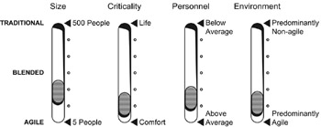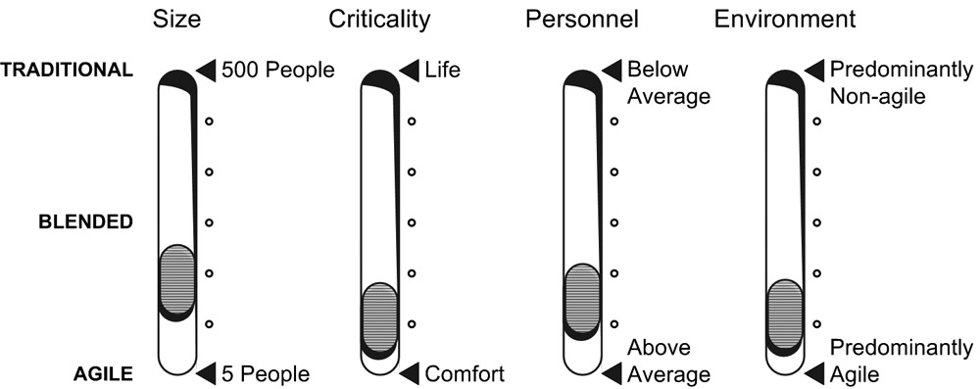
Figure 4.1: The variables for determining a project approach.
As criticality goes up, projects typically employ more upfront planning. In addition, these projects will require greater amounts of process and work products—and the more tested, tried, and proven they are the better. FDD, with its emphasis on upfront modeling and planning, and DSDM, with a defined and thorough set of processes and work products, may be best suited (or at least make the organization behind the project feel more secure) for higher-criticality projects. Again, however, loss of life is not a topic addressed frequently by even these methodologies.

Personnel
Several factors go into determining whether the people on a project are ready and capable to pursue an agile approach. This slider applies to programmers, managers, and customers—basically, anyone who can claim to be on an agile project team. While competent people are required for both agile and traditional approaches, more competent people are required for an agile approach [Boehm04].
Assuming a basic level of competence for every individual, these are the qualities most needed in project personnel:
- Ability to communicate and collaborate
- Technical skill
- Experience with agile development
These qualities are ranked by order of importance and the level of difficulty entailed in attaining this quality when it is absent in an individual.
Every agile methodology requires a project full of people who can communicate effectively and collaborate on at least a basic level. Technical skills are important but not as essential to agile development because a group of amicable (that is, communicative and collaborative) people can help train one another. Experience with agile development is useful but easier to learn than technical skills [Lyndvall02].
Therefore, a lack of agile experience on a team can be overlooked rather easily. Solid agile experience but a lack of technical knowledge can often be overcome. For example, a programmer with lots of experience in C++ and agile development should have a minimal amount of difficulty starting on a project that uses Java and follows XP. However, even truly communicative and collaborative people may begin to encounter real hurdles when they need to learn too much at once, such as the new technology and agile development.

Environment
How a project’s environment affects its ability to go agile is discussed in detail in Chapter 20. The categories of project environment characteristics include the development team, project management, the customer, the process and tools, and the contract. If a project’s environment is not conducive to agile development in one of these categories, an agile approach may still be achievable. Each of the agile methodologies can flex to a certain extent to handle environments that include the following:
- A large and distributed team
- A waterfall plan
- An unavailable or aloof customer
- Heavy process and tools
- Fixed cost and scope
It is important to remember, however, that working in such an environment may both slow the adoption of an agile methodology and limit its overall effectiveness. Additionally, this advice applies to project environments that experience only one of these constraints, possibly two if they are mild, and under no condition three or more.
If a majority of these categories is deemed non-agile, the project team at best may pursue a blended approach, one in which the project selects an agile methodology and adapts as much of it as its project environment will allow. If the project environment is predominantly non-agile, then the team may be able only to gradually select and adopt those agile practices that will still fit within the non-agile constraints of its environment.

SELECTING THE RIGHT AGILE APPROACH
Once a project team has identified one or more methodologies that it is interested in and assessed its compatibility with an agile approach to software development, the team may still find itself considering just how deep a plunge it wants to take into any one methodology in particular or agile development in general. Four possibilities are discussed in this section. They serve to demonstrate the many options available to such teams, and no one option is necessarily correct. Finally, many projects never get nearly as close to the pure implementation as they would like, but they benefit nonetheless.

By the Book
When possible, it is best to adopt an agile methodology by the book. Scrum and DSDM, for example, both highly recommend starting by the book and tailoring it only after a project has become proficient with the approach. XP has occasional and raging debates on this issue, with no certain conclusion but lots of opinions. The important thing about the by-the-book approach is to ensure that the project sliders discussed in the previous section all indicate that the project is suitable for a pure agile application. Implementing XP on a fixed-cost project, Scrum with a dictatorial or abusive customer, or FDD in a CMM environment—without first making adjustments to the approach—is all but certain to result in a train wreck.

Modified or Partial Implementation
A project may modify the methodology as it implements it for several reasons, varying from the desire to substitute a single process with something that better suits the project’s environment to a partial adoption in order to blend an agile approach with an environment that has high regard for traditional values, such as a plan-driven or architecture-first approach.
Process substitution is simply the replacement of one agile process or practice with another. Crystal Clear, for example, specifically endorses this practice. So, for example, a project may follow all of Crystal Clear but use a Scrum-like approach to planning iterations [Cockburn04]. Cross-pollination of processes and practices, after all, has been occurring within the agile methodologies for some time.
More significant is the partial implementation of a methodology. This approach is frowned upon by many strict methodologists, who argue that the project environment must be altered to reflect the values and principles of the methodology before its processes and practices are applied. While correcting the project environment first is a valid recommendation, many project teams simply have no chance of making good on it. The IT organization, long-established and enterprise-wide processes, or an entrenched business may pose a significant rampart that a lone project will not be able to overcome. In those cases, the project that hopes to become agile and has only one or two significant constraints in the way can implement as much of the methodology as its environment will allow. Then, possibly, once the methodology has borne fruit, the project may actually be able to use its progress to argue effectively for the removal of the constraints that prevent full adoption.
Finally, project teams that have only the time, ability, or interest in dabbling in agile development may select a single methodology and begin to incorporate the aspects of it that they find most interesting. Such a project team may also be interested in applying a mix and match approach, as discussed near the end of this section.

Embedded XP
XP stands out among the agile methodologies for being so explicit in how programmers should perform their day-to-day activities. Many projects and even organizations may look to the XP programming practices as how they would like development to be done while (justified or not) preferring a more defined and document-friendly project planning approach. Several agile methodologies that put more focus on planning or work artifacts than XP regularly flirt with its programming practices. Scrum and DSDM, for example, have some established processes for embedding XP programming practices within their planning frameworks [Stapelton03] [Mar04].
One approach to blending Scrum and XP, for example, is to implement Scrum in its entirety while folding the programming-level XP practices. The XP practices to be included are simple design, TDD, refactoring, pair programming, collective ownership, continuous integration, and a coding standard. In this approach, Scrum processes handle the iteration planning, execution, and tracking, and XP practices control and maintain the quality of the system [Mar04].
It should be noted that there are some conflicts specifically between FDD and XP associated with code ownership; FDD has it, and XP espouses collective ownership. This difference of opinion, in addition to FDD’s upfront modeling activities, creates incompatibilities between FDD and XP at a programming level. XP programming practices that may add little value to an FDD project include simple design, refactoring, and even continuous integration.
Finally, an embedded XP approach even extends beyond the world of agile methodologies. The Rational Unified Process (RUP), for example, has an XP add-in.

Mix and Match
There is an option to transition to agile development without following any agile methodology. Instead, a project team may simply identify those processes and practices that it believes may benefit it most. Such a team may even identify practices as it goes, taking the time to select and adopt one or two practices, reassess its situation and needs, and then move on to select the next practices that will help it the most.
The mix and match approach, what some Agilists may more properly refer to as a team tailoring its own methodology, is a very legitimate solution for some projects [Highsmith02] [Cockburn01]. Moreover, a team that finds itself with too many sliders positioned toward a traditional software development approach may find that this is the only way to transition to a more agile approach. However, unless it has a team of crack programmers with solid agile experience, a project is likely to move more slowly when adapting agile processes and practices in this ad hoc manner.
The mix and match approach happens no matter what. Whether the team actually brings the process coach in on the secret and whether they are viewed as hacks or enhancements, individuals and teams are constantly tweaking, modifying, and augmenting whatever processes they are given to use [Oldfield03]. Also, as has been noted previously in this book, whatever helps to make software better, faster, and more useful to the customer should be considered fair game.

Chapter 5: Going Agile
A team can approach the process of going agile from a variety of directions and with a variety of intentions. Some intentions can be very specific: “We want to start doing automated testing and test-driven development.” Others can be more vague and far reaching: “We are already doing a good job at testing, but we want to get agile into our project management.” Others, still, can sound specific but lead to many new questions: “We’ve been given permission to adopt extreme programming, but we must do it while continuing to complete the project.” Occasionally, a team gets the chance to do it by the book: “Management has said we can pause the project at the end of this release and adopt Scrum.” But even this scenario can pose challenges related to the project environment, the team learning process, and individuals, both on the team and business.

IS THE TEAM READY?
Sometimes going agile is a rocky experience. Knowing the project environment and where the team is headed (in addition to going slow) can steady the ship.
Hopefully, any project that is about to start adopting agile development has taken its bearings and knows the very basics of how it will start off in a more agile direction. Nonetheless, the following list may serve as a good double-check:
- Is there a customer?
- What methodology will be followed?
- How closely will the project stick to the guidelines of that methodology?
- Will the project go agile gradually or all at once?
- How well is the project environment suited for the planned changes?
- How much will the project environment need to adapt to meet agile?
- How difficult will it be for the necessary changes to be made?
These are all questions that should have been considered by now. There certainly will not be answers for everything, but if a project team has not at least thought through one or more of these questions, now is the time to do so. Answers to these questions will help a project’s advocates for agile—whether they are programmers, the project manager, a higher level of management, or any combination—determine the steps that need to be taken before going agile, select the specific practices that should be adopted first, identify potential pitfalls, and choose the speed at which everything should proceed.
Preliminary answers to these questions will do. After all, a plan to go agile should be just as flexible as the practices that will be implemented and the project that will implement them.

ANNOUNCING THE TEAM’S INTENTION TO GO AGILE
It really is not in any project’s interest to bill itself as Team Agile. In fact, projects going agile may benefit the most from trying to bring as little additional attention to themselves as is possible. The team will need time to work through even a single practice, to measure its benefit, to tweak its implementation, and ultimately to embrace or reject it. No team wants to have its hands tied to a well-publicized experiment or feel as though it is developing software while under a microscope.

Full Transition
A lot of people are going to know, because the project team will need to have sold the concept to the project’s customer, the business, and upper management. But a team can also draw additional (and unnecessary) attention to itself by foretelling all the valuable things it is going to do with agile and claiming that it will become the role model for the rest of the organization. Such proclamations can actually raise the bar so high that the team will be unable to reach it. They can also build up resentment from other project teams.

Gradual Adoption
A plan based on gradual adoption should result in less immediate attention being focused on the team. First, because the project team will create fewer waves at start-up. Second, because a successful start-up will provide achievements that may be used to justify future changes to the project environment that may be required to implement additional practices and processes. Typically, it is easier to get someone to agree to use something when it is proven to work or at least is closely related to something else that has proven to work.
With this approach, it is even possible that a team will not need to ever make a big deal to anyone about going agile. If the project team has bought into going agile and decided to adopt it one or two practices at a time, the team may choose to put off announcing its new agile tendencies until it needs buy-in from individuals outside the project (such as the customer and higher-level managers) to implement practices such as user stories and frequent releases. The downside to this approach, of course, is that it is slower going than an immediate transition, but this by itself is not a bad thing.
The same approach may apply for a few programmers on a team who want to begin experimenting with agile but for whatever reason are not able to get the project’s manager to seriously consider a full-fledged agile approach. The team may simply identify and adopt an agile programming practice that will not influence its overall velocity. Then, the successful implementation of that one practice may be used to justify a greater time investment for the next one. For example, a team lead might bring up the topic with the PM: “Remember that automated build we started using last month? Well, that went really well, so we’d like to try another agile practice to work alongside it—testing.”
As much as possible, let the results of the team’s foray into agile speak for itself. If the team’s performance is improved, the customer, the boss, and the customer’s boss are all likely to notice. Answering that agile practices were the key to the project’s success will serve the team much better than heralding the results that agile practices are going to bring to the project once they’ve been explained to everyone, and once the team has implemented them, worked through all the issues, and then explained why it all took longer than they thought.

ENCOUNTERING, ADDRESSING, AND OVERCOMING RESISTANCE
A transition to agile development (or even the adoption of a handful of practices) can be met with resistance and even be seen as threatening to a wide variety of individuals and groups. In many cases, people have simply established a specific method of doing things and do not want to change. Overcoming the resistance of individuals and groups can be a key challenge to some project teams that choose to go agile. This may especially be the case in heavy process environments.
There are a lot of types of resistance project teams may encounter when going agile. Ultimately, each must be addressed on a case-by-case basis. Some of the most common are discussed in this section.

People Who Like Meetings and Documents
In many environments, the unfortunate reality is that people are all but encouraged to measure their progress by things that may not actually be productive but are easy to measure, such as the number of meetings they attend or the number of pages written in design documentation. Because such behavior may be the result of years of conditioning, no one can reasonably expect these habits to change overnight. As the team transitions to agile development, these individuals will find reasons to attend and hold more meetings and generate and cling to more documents than would otherwise be necessary. Confronting these individuals directly may not produce desirable results.
The most important thing for programmers on a team with such individuals to do is simply to avoid taking part in any unnecessary meetings or documents initiated by those individuals. The most important thing for the team lead and project manager to do is to be ready to step in if and only if the additional meetings and documents are reducing the productivity of other members of the team.
Agile practices are geared toward specific and useful goals such as fully integrated code and completed features at the end of each iteration. Hopefully, over time, these goals may wean individuals away from their meetings and their documents and onto better measures for defining their personal productivity.

Fears of Micromanagement
Constantly asking for estimates, regularly setting short term goals, holding daily meetings (no matter how short), and frequently checking on progress can stir fears of micromanagement within many sane individuals. When such practices are used in the wrong manner, people are justified in having these fears, but some individuals will not wait long enough to find out whether their fears are justifiable. From day one, these individuals may treat some agile practices and processes with suspicion.
To overcome these fears, project managers and team leads need to emphasize the reasons agile projects use these practices, but they should do so through actions, not words. Managers need to show interest in the obstacles standing in the way of team members and demonstrate that they can and will act quickly to remove them. Furthermore, managers must be respectful of the changeability and uncertainty of estimates [Cohn03]. One sure way to confirm fears of micromanagement is to react negatively when a task turns out to take longer than planned.

Business and Upper Management Do Not Want to Give Up Control
Even when everyone knows that detailed schedules cannot actually be adhered to and estimates are just estimates, it can be very difficult for managers and customers to let go of the project schedules, Gant charts, functionality-specific milestones, and commitment dates they are accustomed to. No matter that few projects in the organization actually meet those targets, managers and customers fear how much worse it would be if the targets did not exist at all.
If simply knowing what is actually going on is the problem, it may help to explain the process used by agile projects to track progress very specifically through the collection of a few reliable metrics, as discussed in Chapter 16, “Reviewing and Reporting Progress.” If control is the problem—that is, management or the business is concerned they will not have a strong enough hand in the direction of the project—then explaining the process of planning iterations and releases and the amount of control provided may be in order (discussed in Chapters 10 through 14). Finally, if there’s just no way around it, and the schedule has to be there and documents have to be written, the project team should still be able to manage a compromise between some agile and traditional processes (see Chapter 20, “Real-World Environments”).
Ultimately, it will take time to change the opinion of managers and customers who have dug into their positions over years of working with projects that miss deadlines, deliver low quality, throw up change control walls, and the like. This is where adopting agile practices and processes gradually may matter most. A team will need early victories and may have to show significant progress before asking others to make significant changes.

Analysts and Testers
Testers and analysts can feel as though they have been given no place within the new vision of an agile project. This certainly will not be the case on all projects, but in some cases the traditional role of the tester may be adopted by programmers, and the traditional role of the analyst will seem to have been divvied up between the customer and the programmer.
In some cases, the roles of these individuals may not change dramatically. Analysts may still work with the customer to define new functionality, act as domain experts, and assist programmers with domain modeling. The organization (or the system) may require enough testing activities that cannot be covered by the programmers alone. In fact, testers may even find their roles enhanced because the project team will be interested in discussing testing at the beginning of the project rather than seeing it as an unavoidable obstacle at the end.
In other cases, however, extra attention will need to be given to these individuals to help them find their place in the new team. Testers may need to learn to work with the programmers throughout the project instead of just near its end. Analysts may need to transition away from heavy documentation and acting as a filter between the customer and the programmers and embrace a role that facilitates a timely and high-quality mode of interaction directly between the customer and the programmers.

When Agile Is a Four-Letter Word
Agile development—or at least discussion of it, opinions about it, and claims to have done it—is becoming ever more common. Unfortunately, there are places where agile has become a dirty word. It may be for completely groundless reasons (somebody told somebody about a team somebody else had worked on), but it is an issue nonetheless. If these opinions appear unalterable and are held by individuals who have influence over the direction of the project, then they really need to be taken into account when determining how the team will adopt agile.
One can imagine the perils awaiting a team that chooses to perform a speedy transition to agile in a hostile environment. In such a situation, even if the team manages a successful transition, once the word agile comes out, the project may not be judged on the merits of its work. In an environment that is unfriendly to agile, gradual and cautious adoption is recommended.
The team may find itself with new options if it can determine the actual concern that is held about agile. Is it something that the team can draw a chalk line around (such as the agile tendency against documentation or toward TDD) and simply agree not to go there? Conversely, the team may need to agree to something extra, such as a separate multi-week phase to perform integration and system testing. Either way, the powers that be may be more amenable if they believe their concerns are being acknowledged and accommodated. Even if the team has to throw out “that whole agile planning thing” to gain approval to implement development-level practices, then it is better off. After six months of successful, continuous integration and test-driven development, perhaps the answer about agile planning will be different.
If it appears that agile itself is simply a tainted term, then the team might make some headway by detaching the practices from agile. In this case, each practice that needs approval in order to be implemented would be presented based on the benefit it would provide to the project and not its association to agile. That does not sound so bad, does it? Someone may also be able to scrape up some literature on the practice that predates agile. This may help if the real concern about agile is that it is new, untested, or unproven.
Chapter 17, “Communication and Collaboration,” and Chapter 19, “People,” discuss topics that may be helpful in addressing issues that arise from resistance in the face of a transition to agile development.

STARTING WITH THE BARE MINIMUM
It is easier to build up from a bare minimum methodology than it is to pare down from a one-size-fits-all approach [Stapleton03] [Cockburn04] [Boehm04]. Starting with too much in the way of process and work products is a problem because too often the superfluous stuff never is gotten rid of. Additionally, with too much process, it becomes difficult to identify what really works and what just gets in the way. When a whole load of process is dumped on a project all at once, a team typically begins to follow bits of the process, but typically the individuals do not follow the same bits. When the team tries to do too much at once, the result may be that it is unable to give a fair shot to anything. Some practices, such as automated unit testing and continuous integration, are of greatest benefit to the team only when they are followed by all or nearly all members of the team. Teams have adopted these and other agile practices and then dismissed them because not every member of the team invested time in their implementation. As a result, the experiment was deemed a failure, and agile was blamed.
Starting with as little process as necessary is a theme that is repeated throughout this book. It is discussed with regard to the creation of documents, the use of tools, and (as already begun) the adoption of agile practices and processes themselves.

ALTERING THE PROJECT ENVIRONMENT
As noted in Chapter 2, “Agile Characteristics,” the best thing to do prior to implementing agile development is to make the project environment as conducive to agile as possible. In an ideal setting, this means training customers and programmers to collaborate with one another, convincing stakeholders and upper management that continuous planning really can produce better results than an upfront plan, ensuring that the project team has the ability to set its estimates and identify the processes it needs to operate most effectively, and focusing everyone on the development and delivery of useful and useable software.
In many environments, such changes simply cannot be made. Whether it is because agile is being advocated by only the programmers on the project or because the organization with which the project exists is simply too large and set in its ways to adjust, the result is the same. The environment cannot be dramatically altered, and the project team will simply have to adjust. Nonetheless, there are still little things that a project team in such a situation may be able to do to shave off some of the roughest edges of a stubborn project environment.

Adjust with Many Microtouches
Requesting that environments or even people change in significant ways can be like poking at a hornet nest without a stick. Often, instead of shifting to a more desired behavior, the organization or individual can actually become defensive and even more difficult to work with. Alistair Cockburn proposes a technique called microtouch intervention for making significant changes in project environments without stirring up a nest full of angry hornets [Cockburn01].
Cockburn proposes a series of small changes intended to have a large impact. Each microtouch consists of a small change in the project team (such as a seating assignment) or a small request of an individual (some sort of simple favor). The effect of these many small but coordinated changes can be significant. Obstacles may be overcome. Goals may become more aligned. Individuals may feel less friction between one another and find more areas of mutual benefit.

Eliminate Waste
Any activity or artifact completed by a project team that does not provide a benefit to the customer is a waste. Depending upon the situation of any given project, examples of such waste may include documentation that does not have an immediate and valuable purpose, requirements analysis that does not result in developed functionality, and even features that are not absolutely required for the upcoming release.
In Lean Software Development, the Poppendiecks present seven categories of waste in a software development project [Poppendieck03]:
Partially done work: This is an investment that has yet to provide any return. Work (such as the fine-grained analysis of a feature) that is left undone can quickly grow obsolete so that it needs to be completely redone. Even when partially done work is completed, it often takes a significant amount of additional time to update and integrate because the system has evolved since the partially done portion was completed.
Extra processes: Documentation, meetings, and official sign-offs all take time to complete. Reducing and removing unnecessary processes is a mantra of agile development and a theme of this book.
Extra features: Adding a feature because it may be needed typically seems like a good idea. We do such things because we are trying to think forward and act instead of having to look back and react. Features that go unused, however, have a real cost associated with them, not only in terms of initial development time but also in terms of integration, tracking, debugging, deployment, and support activities. An extra feature, unfortunately, may be just as likely to necessitate an emergency release as it is to be of benefit.
Task switching: No matter how thin and sharp the blade, matter is always lost when an object is sliced in two. Similarly, whenever someone has to stop and put down one thing in order to pick up another, time is lost in the transition. Teams and individuals complete work most efficiently and quickly by completing one thing before moving on to the next.
Waiting: People cost money and time. Unnecessary waiting, for whatever reason, results in waste.
Motion: Just as waiting is waste, unnecessary movements are also waste. Programmers needing to seek out analysts or the customer to ask a question is waste. Document sign-offs and hand-offs are also motion and, when unnecessary, are similarly wasteful.
Defects: Fixing a defect takes time that could have been spent on something more productive. Defects typically take more effort to fix the longer they go unnoticed. Therefore, adjusting processes to find defects faster can eliminate waste.
Reducing waste lightens the load that the project team needs to carry at any given time, increasing its overall productivity and responsiveness. Demonstrating that a given activity, process, or document may be wasteful in time or money can be a successful strategy to initiate change.

ITERATION ZERO
Agile teams strive to deliver functionality that can be appreciated by the customer at the end of the first iteration. Sometimes, however, it makes sense for the team to focus on building its foundation before delivering functionality. This may be the case especially when a team is new to agile development. Regardless of what practices it initially adopts, a team new to agile development may consider employing an iteration zero strategy. (ASD refers to this technique as Cycle 0 [Highsmith00a].)
An iteration zero does not deliver any functionality to the customer. Instead, the project team focuses on the simple processes that will be required for the adoption and use of most agile practices. From a programming point of view, the features delivered in an iteration zero may include:
- Source control system installed and operational
- Initial build scripts written and checked into source control
- Initial build promotion and deployment scripts written and checked into source control
- Automated test framework selected and implemented with an empty test suite
- Construction of a rudimentary continuous integration process
One good method of performing these activities is to wrap them around a Hello World program. Hello World can then be the first piece of functionality to pass a test in the unit test framework. It can be the first thing to be automatically compiled, run through the continuous integration process, checked into the source control, promoted to the testing environment, and automatically deployed.
From a management point of view, iteration zero outputs may include:
- Initial list of features identified and prioritized
- Project planning mechanism (spreadsheet, simple database, index cards, or other planning tool) identified and agreed upon
- Identification of and agreement upon a team customer, essential stakeholders, and business users and the nature of the iterative planning process, such as the time of planning meetings and the length of iterations
The activities performed in an iteration zero are analogous to learning the letters and numbers of a foreign language. Before learning to read a foreign language, we need to know how to pronounce the letters in that language. Similarly, before writing tests, we need to have a unit test framework, and before prioritizing and planning features, we need to have a simple system to track and organize those features. Finally, assigning this foundation-level activity to a single short iteration timeboxes the work, which guards against gold-plating, analysis paralysis, and a host of other project villains.

DISCONTINUE A PROCESS ONCE IT HAS SERVED ITS PURPOSE
The processes employed by project teams can be split into two categories. Some processes need to be followed all the time, such as deploying the new release of an enterprise application into the production environment. Other processes serve to train and cement new habits, such as sticking a mark on a calendar to signify that the last daily run of the team’s new automated test suite finished successfully. While the first type of process may be altered or amended, it is something the team will always need to do. For example, the risk of letting someone shove the new release of an application into an enterprise environment without first backing up the old system, then bringing down other dependent systems, then deploying the new system, and then running a system diagnostic is just too great.
The latter kind of process, however, should be removed. Transitioning to agile development may entail a number of these little processes—such as asking at the daily stand up whether anyone did not check in their code yesterday (see Chapter 17), tracking a temporary metric (see Chapter 16), or citing specific rules that must be followed during release planning (see Chapter 13, “Small Releases”). They will likely be necessary to help team members break old habits and learn new ones. However, each process must be discarded once it has served its purpose. If not, people may continue to strive to meet the goal of the process even though it is no longer particularly valuable to the team. If a multitude of little processes begins to accumulate, they can bog down the team. Finally, in an extreme scenario, too many mostly harmless but useless processes left in place can even threaten morale.

FALSE AGILE PRACTITIONERS AND PROJECTS
False agile practitioners are not necessarily disingenuous or ill-intentioned individuals. They may honestly believe they are doing agile development, for example, because this is what others they have worked with have told them. Further, as stated repeatedly throughout this book, there is nothing wrong with melding agile practices onto a traditional software development process (or vice versa, for that matter).
What is dangerous about false agile is the discordance and potential failure that will ultimately result when a project founded on a standard development process declares itself agile, does not change any of its non-agile underpinnings, and yet begins to take on agile habits without a genuine understanding of the practices and principles on which they are based. Such a project is headed down a bad path for a variety of reasons.
First, false agile projects may only do themselves more harm by trying to do some of the things agile projects do, such as not freezing requirements and releasing often, without following many of agile development’s disciplined practices, such as automated testing, continuous testing, and simple design. Second, there is a significant potential for real misunderstandings between different parties on the project. Stakeholders and users who have been sold on iterations and user stories may not recognize that many agile practices require their regular participation and that estimates are not timeline commitments. An old-fashioned manager who controls the information conduit between programmers and users but does not really comprehend user stories could wreak absolute havoc on timelines and deliverables by miscommunicating estimates, requirements, and priorities. Ultimately, false agile practitioners and projects threaten real harm to both themselves and the movement as a whole.
Traditional development processes masquerading as agile can sometimes be obvious. At other times, however, some real investigation may be necessary. Pete McBreen, in an insightful article titled “Pretending to Be Agile,” has provided a list of the top 10 signs that a project is just pretending to be agile [McBreen02]. The items below paraphrase his list:
- The project plan slates the first release 18 months into the project.
- Deliverables are handed off from analysts to architects and architects to developers.
- Architects are proud of not writing any code.
- The project hierarchy puts programmers and testers at the end of a long food chain.
- The team keeps asking the business to sign off on requirements.
- Programmers complain when change requests sneak through change control.
- Two months into the project and the team cannot show any working code.
- The team is encouraged to document instead of communicate.
- Testing and quality assurance act as the end of the process and not part of the development team.
- Tasks are assigned to individuals who complete them alone.
The astute observer may note that several of these items relate to project culture. This is why one must use care and caution when melding agile practices and a standard development process. Most agile processes are predicated on the four core agile values: individuals and interactions, working software, customer collaboration, and responding to change. When some or all of those values are not there, one must evaluate the agile practice and the non-agile project to make sure they are still an appropriate fit. This means employing the advice discussed earlier in this chapter and elsewhere in this book.

STARTING MONDAY: MEASURING THE TEAM’S PROGRESS
Some project teams may want to measure their progress at adopting agile. A team that is interested in doing this might use the following scale to rate its progress toward achieving agile nirvana:
- The project has decided to start implementing agile development.
- The project has successfully implemented its first agile practice and has posted a copy of the Agile Manifesto in inch-high letters on a common wall near the team’s location.
- The project has adopted a second practice while collecting metrics and holding review meetings to measure its level of agility.
- The project is regularly adopting additional agile practices and actively monitoring its level of agility.
- The project has not checked its level of agility for months and is altogether focused on adopting or adapting any practice that will result in better communication, higher quality code, and a system that most accurately meets the needs of the business.
The point? Project teams should not fret over how agile they have or have not become. Rather, if a team needs to measure progress, it should focus on whether it and the business are communicating better; whether the code is cleaner, easier to maintain and less prone to defects; and whether, ultimately, the business is receiving more of what it has been asking for. Ultimately, a team should not really care whether it is more agile if all the rest of this activity is taking place.

Chapter 6: Agile Practices
Agile practices are the things that agile teams do every day to write quality code, deliver useful features, plan and track progress, and react to change.

WHERE TO START?
If a team is not starting a brand new project with agile development—or unless that team has been given permission to pull its live project to a full stop, distribute books, hold lots of discussions, and start again at half-speed—the team will have to figure out how it is going to start phasing in agile practices. This is an activity that will require some thought and attention. Simply touting agile practices and then expecting the team to find its way toward agile nirvana, for example, will likely result only in a confusion of half-adopted practices.
Every team needs a plan for adopting agile practices. Teams with plenty of time to spare should seriously consider simply selecting an agile methodology and adopting all its processes at once by the book—no joke. Assuming that team does not have significant quantities of spare time on its hands, the plan can be very simple. First, identify one or more practices to adopt. Second, implement the practice or practices, evaluate the implementation, and make adjustments as necessary. Third, either accept or reject the continued use of each practice. Finally, return to the first step. This process is illustrated in Figure 6.1.
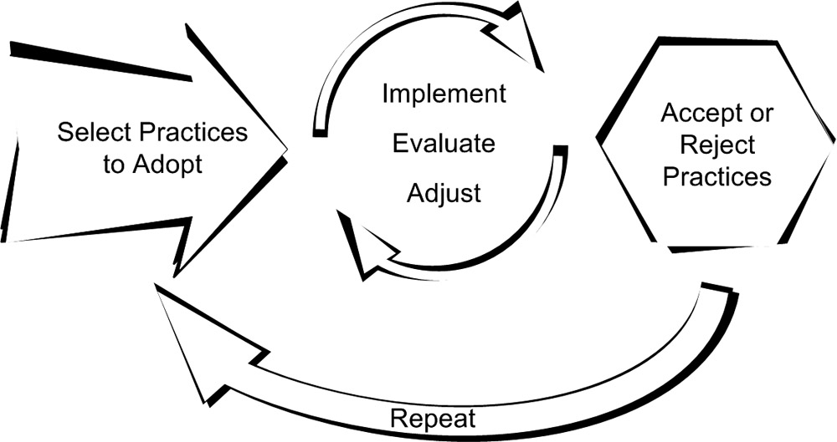
Figure 6.1: The ideal model for rolling out agile practices.
When going agile, the details behind any two plans will likely be different, although potential similarities are discussed later in this chapter and elsewhere in this book. The way a team implements agile practices depends on the methodology it is following, the speed at which it is adopting agile, and the project level that is being targeted (development, management, or both). A lot will depend on the individuals on and associated with the team. A lot may depend on the company culture and the technology that is being used.
Ultimately, each team going though this process must come up with its own right answer. When following a named agile methodology, a project team may sometimes come across a specific process (and practice or work product) about which the team is unsure. The team as a whole and even key individuals may be uncertain whether to follow the recommendation of the methodology or refrain from implementing the specific process. Boehm and Turner suggest a simple but intriguing query that may be asked in such a situation: Is it riskier to adopt or not adopt the process in question? The answer to this query may not decide the fate of the process in question, but it may help to frame the debate [Boehm04].
Speaking for most any process, if the project team is responding positively and the results are easy to perceive, keep it up. If a new process causes strife and its benefit cannot be easily discerned, then the project team should stop doing it, evaluate what has been done, and choose a different direction, which may mean trying the same process again or dropping that process and trying a different one.

SELECTING THE NEXT PRACTICE
The following sections discuss three methods that may be used to select the next practices the team will adopt.

Current Worst Problem
This approach asks where the team is hurting most. Next, is the team hurting most at the development or management level? Is the problem related to testing, integration, planning, or communication with the customer? The rationale behind this approach is that you are continuously zeroing in on that area where the team should be most willing to throw its whole weight behind a more agile solution.
The approach is based on the following process (which is a modification of one proposed by Don Wells) [Beck99]:
- Identify your project’s worst problem.
- Pair it with the agile practice that best addresses it.
- Get buy-in from the relevant parties.
- When that is no longer your worst problem, repeat.

Biggest Bang for the Buck
What agile practice, implemented today, could deliver the best combination of fastest and greatest return on investment? This practice may be the team’s current worst problem, but it does not have to be. The biggest bang for the buck should be something that takes limited time to implement, has the greatest likelihood for success, and will have a visibly positive effect on the project. It may be an automated build or short iterations.
There are two major benefits to selecting a practice in this manner. First, the swift and successful implementation of one or two agile practices can be a boost to morale and rally the team around the effort to go agile. Second, if necessary, the results of that swift and successful implementation may be used to persuade the powers that be to permit the project additional latitude in adopting agile.

Easiest Thing First, Hardest Second
This approach, which is a strategy of Crystal Clear, combines the previous two approaches. Initially, it steers the project team toward an “early victory” to boost morale and build team confidence. Then the team takes its newfound morale and confidence and turns toward tackling its worst problem. The strategy cautions that the team should ask if its hardest problem is still too hard (is success too uncertain or will it come at too high a cost). If so, the team should zero in on the hardest problem it has where success is very likely [Cockburn04].

REJECTING A PRACTICE
Not every practice is suitable for every project team. While one would hope that a team typically understands itself and agile development well enough to know in advance which practices are good matches, this is not always the case. No team should be afraid of abandoning an agile practice now and then if that practice has been deemed an unsuitable fit by the team. A team loses momentum when it begins flailing at a practice that it is unable to implement. It will regain much of that momentum simply by dropping the failing practice. It may then gain additional momentum by selecting another, better-suited practice to implement.
If a team finds it necessary to abandon a practice, then it should take the time to evaluate why that practice was rejected. Some important questions to consider are these:
- Was there another agile practice that the team should have implemented before trying to implement this practice?
- Did everyone associated with the practice (members of the team, the PM, and the customer) really understand the practice before the team attempted to implement it, and do they really understand it now?
- Is the project trying to go agile too quickly?
- Is the project going agile too slowly?
- Did the practice fail simply because there was no second or third practice to help reinforce it?
- Was there something about the project’s environment or technology that caused the implementation of the practice to fail?
- Should the team attempt another implementation of this practice in the future?
- Are there other practices similar to this one that the team may encounter trouble implementing?
Answers to these questions may lead a team to all manner of conclusions and actions. These might be rather simple and basic, such as a better understanding into selecting future practices to adopt, or they might have wider ranging effects, such as a decision to alter its physical location or relationship with the business. Ultimately, what is essential is the determination to do something with the information gleamed from the postmortem.

ADOPT PRACTICES BEFORE TOOLS
Agile practices are meant to be adopted and adapted by teams in order to help them produce better, more valuable functionality faster. Tools also can help us do things better and faster, but tools are not as malleable as practices. Tools implicitly retain the assumptions and biases of their makers; this can cloud, skew, or impede the learning process for teams that are trying to adopt both a new agile practice and a tool related to that practice. People may learn the tool instead of the practice and therefore go through the motions of the practice without comprehending its real value or actually benefiting from that practice. Worse yet, tools can take a significant amount of time to put in place and learn. You do not want to be on a team that has the misfortune of trying an agile practice through the implementation of a tool only to go sour on the practice because team members could never master the tool.
XPers often argue that paper, pencil, and marker board are the tools a team should always start with [Beck99]. This is valuable advice. Once the team learns a practice and grows to value it, then of course it can and should consider tools to make that practice even more useful. See Figure 6.2.
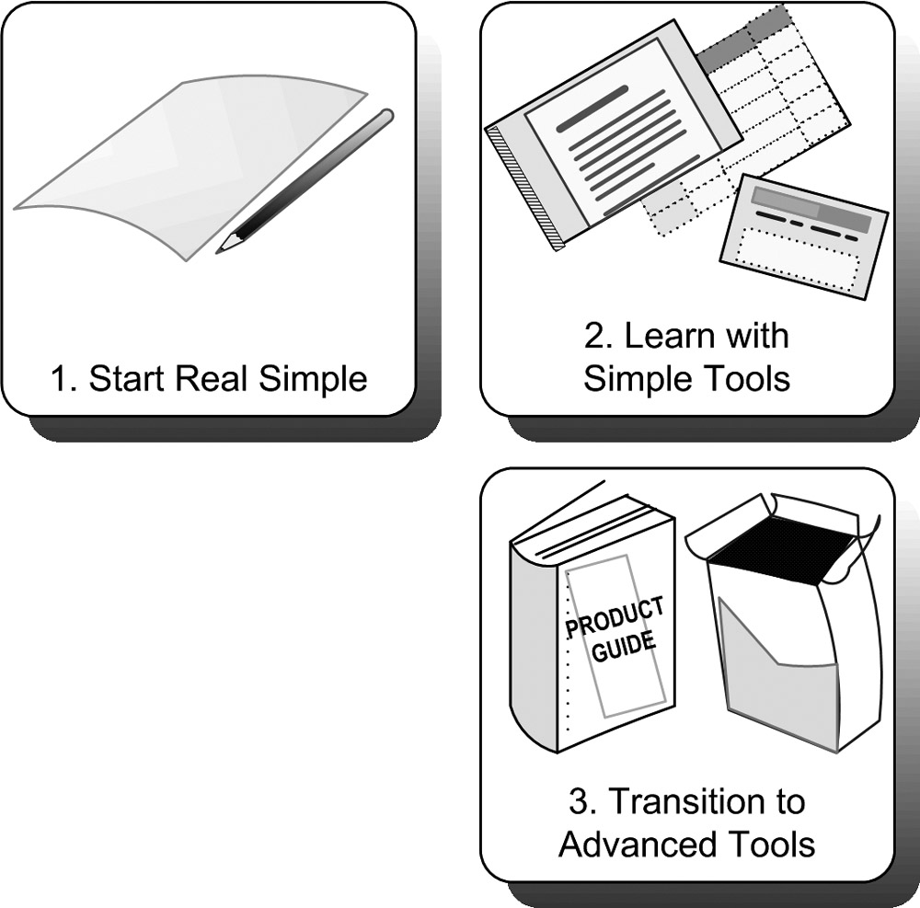
Figure 6.2: Adopt agile practices before complex tools.
There are notable exceptions to this rule. Some agile practices such as automated builds and automated testing benefit from or rely on little tools (such as Ant and JUnit). Additionally, a spreadsheet application is a fine place to start cataloguing and tracking planned features and user stories. Finally, as we have discussed earlier, teams cannot always control everything that goes on with their project environment. Sometimes a team is required to use a given tool for project activities, such as a third-party testing or planning tool. In such cases, the team may need to take both extra time and extra care to learn the practice and implement it through the requisite tool.

LEARN PROGRAMMING PRACTICES IN PAIRS
Even if a project team has no pair programming experience, it could benefit from trying to learn and teach many of the agile programming practices such as automated testing, simple design, refactoring, test-driven development, mock objects, and ObjectMother through pair programming. The practice is described in Chapter 7, “Design and Programming,” but at its most basic, pair programming is simply two programmers sitting down at one workstation to complete a programming task.
There are two reasons for working in pairs when adopting agile programming practices. First, two programmers working together will typically learn faster and with fewer mistakes than one programmer learning on his own. Second, once the first pair on a team has learned the practice, then that pair can break up; each programmer can then pair up with and teach the practice to another member of the team. This can happen while each pair is programming real code and contributing to the completion of the project. To be clear, using pair programming in this fashion does not mean that the entire team needs to be pair programming the entire day or even half the time. If pair programming sessions were targeted to occur only at those times when two heads will most certainly be able to learn faster than one, it should be easy to imagine how a pair-learning approach can cause new agile practices to ripple quickly through the project team—possibly without even causing a significant disruption in the completion of work.

AGILE PRACTICES IN THIS BOOK
The agile practices discussed in this book are listed on the back cover. The practices themselves are distributed throughout the book and discussed in the chapters to which they most directly apply. The majority of these practices are called out specifically as agile practices, which is really just a label to indicate that the practice will be discussed in a specific manner, as explained in this section. The list contains two practices central to agile development—small releases and short iterations—that serve as the foundation for Chapters 13, “Small Releases,” and 14, “Executing Iterative Development,” respectively. Finally, the list contains several other agile practices and techniques that, while discussed with less focus in this book, can be an important aspect of some implementations of agile development.
67

Agile Practices Explained
Each practice that is called out as an agile practice is broken into up to six sections, allowing for easy location of important information.

Purpose and Benefits
A short explanation of the rationale behind the use of the practice and what value it will bring to a project team. This section, plus the short blurb that precedes it, should provide someone who knows little or nothing about the practice with the information he needs to determine whether the practice could suit his needs and whether he should continue on and read more about it.

Prerequisites
Things a team should or must have in place prior to implementing the practice. Typically this section will include other agile practices. Sometimes it will include other project environment characteristics. This section should help project teams determine whether they are ready to begin a practice. If it is omitted, then there are no prerequisites for the practice.

Detail
This section provides all the specifics required to learn and adopt a practice. Typically it is included only when an agile practice is less well known or when that practice is not well documented elsewhere.

Implementation
An in-depth discussion about how to implement the practice in everyday project environments. The section includes practical information on how to introduce the practice on both new and existing projects and how to make the most of it.
When a detail section is not included for the practice, this section will also provide a basic overview of the inner workings of the practice.

Opportunities and Obstacles
This is a mix of notes on the practice. Most typically, the section addresses extraordinary hurdles the team may happen upon and highlights potential opportunities that may come from adjusting or extending the team’s use of the practice.

See Also
This section includes a list of other online and print resources that may prove useful when implementing the practice. Except on rare occasions, this section avoids revisiting See Also links already listed in Chapter 3, “Agile Methodologies,” or materials listed in Chapter 21, “Seeking Additional Assistance.”
Whenever possible, freely available and online (but trustworthy and credible) resources have been included in this section, so the reader does not get the feeling that every time he wants to explore a topic further, he needs to run out and buy another book.

Why These Practices Were Chosen
Obviously, there are more agile practices than those specifically called out and discussed in this book. This book addresses the practices that it does for one or more of the following reasons:
- It is a core practice of multiple agile methodologies
- Benefits can be reaped from its application and acceptance in a wide variety of project environments
- It relates to other material discussed in this book
Just like the children of Lake Wobegon, all agile practices are above average, regardless of whether they are mentioned by name in this book.
Finally, the astute observer may notice that most of the agile programming practices discussed in this book (specifically those discussed in Chapter 7 and Chapter 8, “Testing”) originated out of XP. Of all the agile methodologies, XP is the only one to prescribe in detail how programmers should go about their design, development, and testing activities. The other methodologies only go so far as to specify the duration and nature of iterations, permit the simultaneous execution of analysis and design and development activity, or define the non-software artifacts that the programmers should produce and deliver. This lack of deeper programming-level direction on the part of the other methodologies may be evidenced by their tendency to tag-team their more management-level approach with XP programming practices. This is evidenced most often with Scrum and DSDM.

